 | 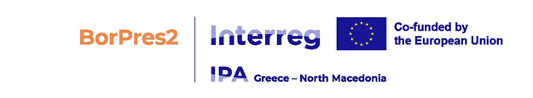  Municipality of Resen
SERVICE CONTRACT
Financed by Commission financing decision n° C(2022) no. 8646/23 Nov 2022

Nº 09- 1137/________

financed from the general budget of the Union
MAIN CONDITIONS
Municipality of Resen
Square Car Samoil no.20, 7310 Resen, Republic of North Macedonia,
(‘the contracting authority’),
represented for the purposes of the signature of this contract by the authorised representative indicated in the respective field under “SIGNATURES” below
of the one part, and

Contractor’s full official name]
Legal form: [Contractor’s official legal form]
Registration number: [Contractor’s statutory registration number or ID or passport number]
Official address: [Contractor’s full official address]
VAT: [OPTION for contractors with VAT: VAT registration number]
(‘the contractor’)
represented for the purposes of signing this contract by the authorised representative indicated in the respective field under “SIGNATURES” below,
on the other part,

HAVE AGREED as follows:
1. Subject matter
The title of this contract is: “Development of complete technical documentation for construction of BORPRES2 hiking trials ”
The terms and conditions applying to this contract are laid down hereafter and in the special and general conditions and their annexes. They shall be deemed to form and be read and construed as an integral part of this contract in the order described in the special conditions.
2. Contract value
The maximum amount covering all purchases under this contract is [currency] [insert amount (insert amount in words)].]
3. Entry into force and duration
This contract enters into force on the date on which the last party signs it.
The maximum duration of the performance of the contract is 4 months from the date this contract enters into force (countract is signed by both sides).
4. Bank account
Payments shall be made in accordance with the special conditions into the following bank account:
Name of bank: [insert bank name]
Exact denomination of account holder: [full name of account holder]
Bank account number: [insert bank account number].

Signatures

For the contractor |  | For the contracting authority
 |  | Jovan Tozievski, Mayor
Endorsed for financing by the European Union*
* The European Union is not a party to the contract, shall not be subject to any obligation in connection therewith and shall not be involved in any dispute settlement, including arbitration proceedings, which may arise therefrom.

Provided it is a freely convertible currency.

