Deliverable 3.6.3: Studies for the most efficient electric minibuses route schedule per Municipality

Study for Resen Municipality

by
University of Patras

Table of Contents
1. Introduction 3
2. Data Collection 3
2.1. General Information 3
2.2. Electric vehicles characteristics 3
2.3. Collected data 3
3. E-minibus routing 3
3.1. Route 1 to Stenje 3
3.2. Route 2 to Evla and Bolno villages 3
3.3. Route 3 to village Gorno Krushje 3
3.4. Route 4 to village Sopotsko 3
3.5. Route 5 to village Zlatari 3
3.6. Route 6 to village Ezerani 3
3.7. Route 7 to villages Dolno Dupeni and Brajchino 3
3.8. Route 8 to Prespes-Florina-Bitola-Resen 3
4. E-minibus scheduling 3
5. Summary 3

Figure list
Figure 1: The cross-border area of Bitola, Resen, Prespes and Florina 3
Figure 2: The City Hall of Resen (top view) 3
Figure 3: The City Hall of Resen (front view) 3
Figure 4: Resen Municipality (Source: Google Maps) 3
Figure 5: The village of Stenje in Resen (Source: Google Maps) 3
Figure 6: The village of Stenje in Resen (Source: Google Maps) 3
Figure 7: Evla and Bolno villages in Resen (Source: Google Maps) 3
Figure 8: Evla and Bolno villages in Resen (Source: Google Maps) 3
Figure 9: Village Gorno Krushje in Resen (Source: Google Maps) 3
Figure 10: Gorno Krushje village on Resen (Source: Google Maps) 3
Figure 11: The village of Sopotsko in Resen (Source: Google Maps) 3
Figure 12: The village of Zlatari in Resen (Source: Google Maps) 3
Figure 13: The village of Zlatari in Resen (Source: Google Maps) 3
Figure 14: The village of Zlatari in Resen (Source: Google Maps) 3
Figure 15: The village of Ezerani in Resen (Source: Google Maps) 3
Figure 16: The village of Ezerani in Resen (Source: Google Maps) 3
Figure 17: The villages of Dolno Dupeni and Brajchino in Resen (Source: Google Maps) 3
Figure 18: The village of Dolno Dupeni in Resen (Source: Google Maps) 3
Figure 19: The village of Brajchino in Resen (Source: Google Maps) 3
Figure 20: Resen center and the villages around it 3
Figure 21: The whole map of Resen and the villages around it 3
Figure 22: Route 1 to Stenje village 3
Figure 23: City Hall in Resen Center 3
Figure 24: Stenje village 3
Figure 25: Route 1 to Stenje School and intermediate stops 3
Figure 26: The three types of stop 3
Figure 27: A typical traffic dynamic scenario on City Hall Resen 3
Figure 28: Speed limits in Resen center according to “Google Maps: Traffic” 3
Figure 29: The position-time diagram for route 1 to Stenje School 3
Figure 30: Route 2 to Evla and Bolno villages 3
Figure 31: City Hall in Resen Center 3
Figure 32: Evla village 3
Figure 33: Route 2 to Evla and Bolno villages and the intermediate stops 3
Figure 34: A typical traffic dynamic scenario on City Hall Resen 3
Figure 35: The position-time diagram for route 2 to Evla and Bolno villages 3
Figure 36: Route 3 to Gorno Krushje village 3
Figure 37: City Hall in Resen Center 3
Figure 38: Gorno Krushje village 3
Figure 39: Route 3 to Gorno Krushje and intermediate stops 3
Figure 40: A typical traffic dynamic scenario in City Hall Resen 3
Figure 41: The position-time diagram for route 3 to Gorno Krushje village 3
Figure 42: Route 4 to Sopotsko village 3
Figure 43: City Hall in Resen Center 3
Figure 44: Sopotsko village 3
Figure 45: Route 4 to Sopotsko village and the intermediate stops 3
Figure 46: Typical traffic dynamic scenario in City Hall Resen 3
Figure 47: The position-time diagram for route 4 to Sopotsko village 3
Figure 48: Route 5 to Zlatari village 3
Figure 49: City Hall in Resen Center 3
Figure 50: Zlatari village 3
Figure 51: Route 5 to Zlatari village and intermediate stops 3
Figure 52: A typical traffic dynamic scenario in City Hall Resen 3
Figure 53: The position-time diagram for route 5 to Zlatari village 3
Figure 54: Route 6 to Ezerani village 3
Figure 55: City Hall in Resen Center 3
Figure 56: Ezerani village 3
Figure 57: Route 6 to Ezerani village and the intermediate stops 3
Figure 58: A typical traffic dynamic scenario in City Hall Resen 3
Figure 59: The position-time diagram for route 6 to Ezerani village 3
Figure 60: Route 7 to Dolno Dupeni and Brajchino village 3
Figure 61: City Hall in Resen Center 3
Figure 62: Dolno Dupeni and Brajchino villages 3
Figure 63: Route 7 to Dolno Dupeni and Brajchino villages and the intermediate stops 3
Figure 64: A typical traffic dynamic scenario in City Hall Resen 3
Figure 65: The position-time diagram for route 7 to Dolno Dupeni and Brajchino villages 3
Figure 66: The new map imported in Aimsun Software for the tourist route to all four municipalities 3
Figure 67: Route 8 to the four municipalities of the cross-border region 3
Figure 68: Route 8 to the four municipalities and the intermediate stops 3
Figure 69: A typical traffic dynamic scenario in Florina Municipality Multipurpose Hall 3
Figure 70: A typical traffic dynamic scenario in Prespes Town Hall (Agios Germanos) 3
Figure 71: A typical traffic dynamic scenario in Resen Town Hall 3
Figure 72: Position-time diagram for route 8 to the four municipalities 3
Figure 73: E-minibus energy reserve, in kilometers remaining during a day 3

Table list
Table 1: Routes suggested by Resen Municipality 3
Table 2: The Google Maps: Traffic color code about speed limits 3
Table 3: Length and duration of each route 3
Table 4: The suggested e-minibus scheduling 3
Table 5: The suggested e-minibus scheduling for the tourist route 3
Table 6: The e-minibus energy reserve (to the four municipalities), in kilometers remaining during a day 3

Introduction
This deliverable describes the study about routing and scheduling in the Municipality of Resen. It is part of the project “Integration of Green Transport in Cities” with acronym “Green Inter-e-Mobility”. This project proposes an intelligent green public transportation system to improve urban mobility and increase sustainability in cross-border regions. Integration of the new system with upgraded infrastructure is expected to reduce travel time, thus enhancing mobility options and supporting Vulnerable-to-Exclusion (VTE) groups, such as elderly and students. The new system is also expected to promote energy efficiency thus strengthening network sustainability in the cross-border regions. The new integrated cross-border system will support work and school trips in Western Macedonia Region of Greece (Florina and Prespes Municipalities), and Pelagonia Region of North-Macedonia (Bitola and Resen Municipalities).
Main project outputs include the enhancement of the tourist stream towards the cross-border area and enhancements of the cross-border cultural relations. This is to be accomplished through the establishment of the transnational Bitola-Florina tourist route, and the facilitation of students in their daily transport and of residents (elderly, disabled, distant-residents) in their daily on-demand transport in all four Municipalities. Further, the optimal route scheduling and the realization of transport by e-vehicles will greatly reduce their transportation expenses in the two regions through a 20-year horizon.
Through the cross-border approach, including the partners’ cooperation during the development and operation phases, the Municipalities will benefit by the mutual exchange of know-how and experiences among the cross-border actors and end-users of the e-vehicles. Moreover, the public, through the partners’ joint awareness initiatives for green mobility, and by making use of the new technology, will participate to environment-friendly concepts and actions. Also, the establishment of the cross-border electric minibus route between Florina and Bitola will be combined with other cultural activities and strengthen the relations between the populations of the two countries.
The project added value is multi-faceted, as it includes the environmental conservation of the cross-border area, the touristic promotion of the region and the facilitation of the area residents in their daily transport.
From the above, long-term benefits to the two regions will include: (a) saving transport and maintenance cost; and environmental benefits through social media, conferences attendees, seminars, (b) the fact that the electric vehicles, especially when they are combined with solar charging, can serve as an important touristic attraction for the area, especially for thematic tourists. In view of rapidly increasing environment-sensitive and thematic tourism, the EVs provide added value to the touristic development of the area.
In what follows, the deliverable will provide seven routes to the main villages of the municipality, Stenje, Bolno, Krushje, Sopotsko, Zlatari, Ezerani, Brajchino, and one tourist route to all four municipalities (Prespes, Florina, Bitola and Resen); and one schedule (given that one e-minibus will be available) for Resen Municipality. The e-minibus mixed cycle autonomy will be 200km, and city cycle autonomy will exceed 300km. The average time needed for charging fluctuates around 4 hours.

Data Collection
In this section Resen Municipality’s preferences, as well as area’s important and busy locations are listed. The routes and schedules created in the next sections are taking into consideration these preferences.

General Information
In order to create a route schedule for Resen Municipality, there is a need to collect quantitative data on current mobility needs and requirements as well as the ways these are being addressed. There is a need for data about the modes that local citizens use for their daily transport, as well as the corresponding trip characteristics, schedules and itineraries. Next, it is essential to focus on the exact mode, in this case buses, and examine the best alternatives for that mode. Effective route planning and scheduling require the best possible awareness of public needs, including origins and destinations. Given that information, the designer proposes trip routes, stops and schedules.
However, public needs are not the same across the four municipalities under study. Public transit networks have their own characteristics and properties across municipalities, and these were taken into consideration when designing routes and schedules. In particular, design requirements included the positions of stops and their popularity, which are related to citizen needs and requirements for education, fitness, recreation, health and markets. Toward this objective Resen Municipality provided a list of possible transit stops, and this is included in section 2.3.

Electric vehicles characteristics
The intelligent network of the electric vehicles for Bitola Municipality consists of one electric minibus (e-minibus) and one electric utility car that will be employed for transporting tourists and students along the routes, as well as residents, especially elderly, disabled and distant-residents, on-demand. The e-minibus will have seven seats and the electric utility car will have five seats. The combined cycle autonomy of the 5-seat utility electric car will be 270km, and for the city cycle, 389km. Regarding the 7-seat e-minibus, mixed cycle autonomy will be 200km, while city cycle autonomy will exceed 300km. Three routes per municipality, averaging 10 km each, will serve on average 25 citizens daily. Additionally, a cross border route from Bitola to Resen, Prespes and Florina will serve locals and tourists who desire to travel in the cross-border area. The following image shows the cross- border area.
Bitola
Florina
Fl;v
Prespes
Resen
Figure 1: The cross-border area of Bitola, Resen, Prespes and Florina

In order to charge the two electric vehicles of the municipality of Bitola, a proper charging station will be constructed, and a grid-connected photovoltaic (PV) system that produces electric energy will be installed. The photovoltaic panels will be installed in the municipality of Resen, on the roof of the City Hall of the area. Figure 2 shows the location of the selected building. The start and endpoint of each route will be the Sports Hall, where the charging of the electric vehicles is feasible.

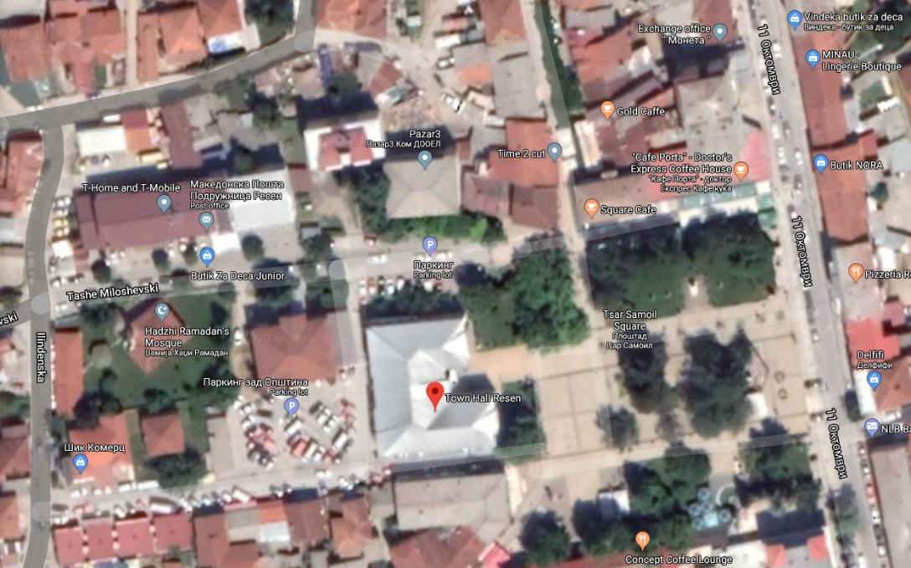
Figure 2: The City Hall of Resen (top view)

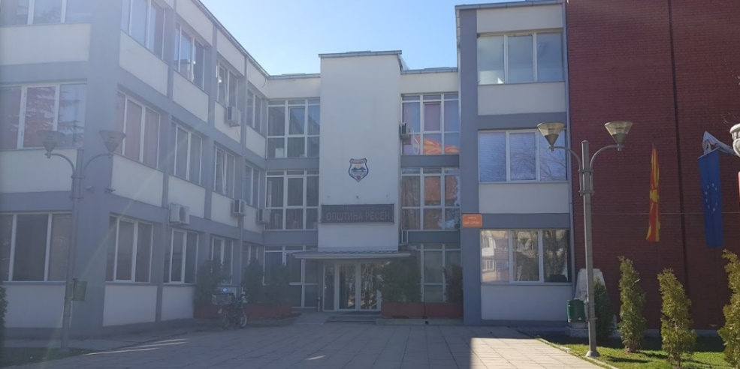
Figure 3: The City Hall of Resen (front view)

Collected data
For assisting in the design of schedules, Bitola Municipality provided a list of possible routes and the corresponding stops. City Hall is both the start and endpoint of each route because of the charging station in the Sports Hall of the area. In the Municipality of Resen no public transport is established. The population uses private transport with private cars. The line transport is used by students and passengers with minibuses. The minibuses are used by 150-180 students and around 30-50 persons per day. Municipality of Resen owns one bus for students, and it is used by around 100 students. The transport of students is scheduled to transport students and connects the schools. Also the municipality owns a minibus for people with disabilities. This is used by 15 persons and 10 students with disabilities per day. Figure 4 shows the location of Resen Municipality, while table 1 shows the routes suggested by Resen Municipality, according to the locals’ needs.
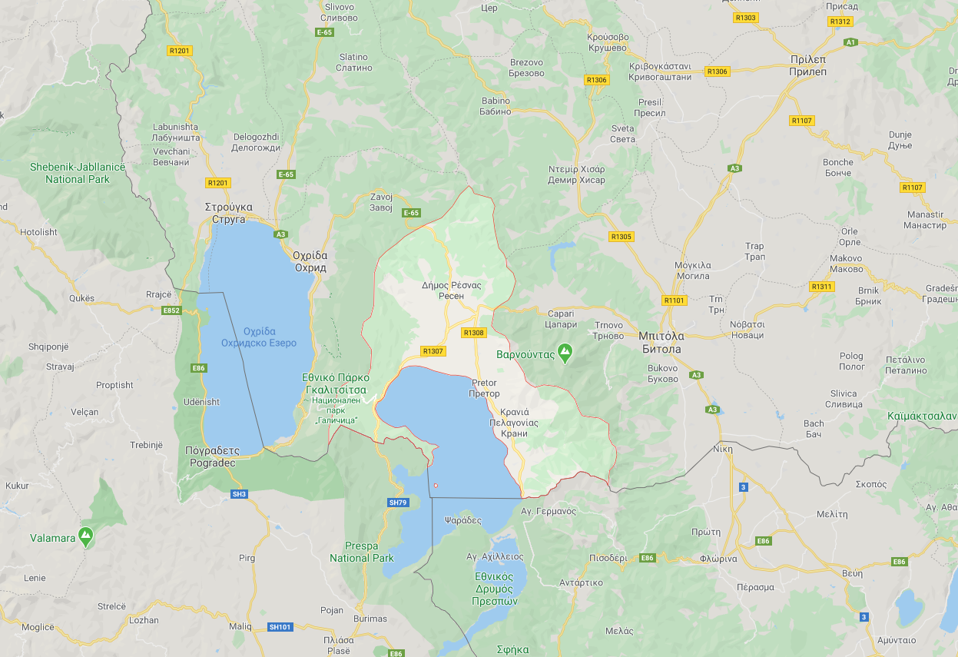
Figure 4: Resen Municipality (Source: Google Maps)

Table 1: Routes suggested by Resen Municipality
Route 1 |  | Stenje
Stops | 1 | Resen
 | 2 | Stenje
 | 3 | Resen
Route 2 |  | Bolno
Stops | 1 | Resen
 | 2 | Evla
 | 3 | Bolno
 | 4 | Resen
Route 3 |  | Krushje
Stops | 1 | Resen
 | 2 | Krushje
 | 3 | Resen
Route 4 |  | Sopotsko
Stops | 1 | Resen
 | 2 | Sopotsko
 | 3 | Resen
Route 5 |  | Zlatari
Stops | 1 | Resen
 | 2 | Zlatari
 | 3 | Resen
Route 6 |  | Ezerani
Stops | 1 | Resen
 | 2 | Ezerani
 | 3 | Resen
Route 7 |  | Brajchino
Stops | 1 | Resen
 | 2 | Dolno Dupeni
 | 3 | Brajchino
 | 4 | Resen

The first suggestd route drives to the destination of Stenje. Stenje (North-Macedonian: Стење) is a village in the Resen Municipality of North-Macedonia. It is located on the shores of Lake Prespa, near the Macedonian-Albanian border and Galičica National Park. Today, the village has 438 residents. Figure 5 shows the location of Stenje village.

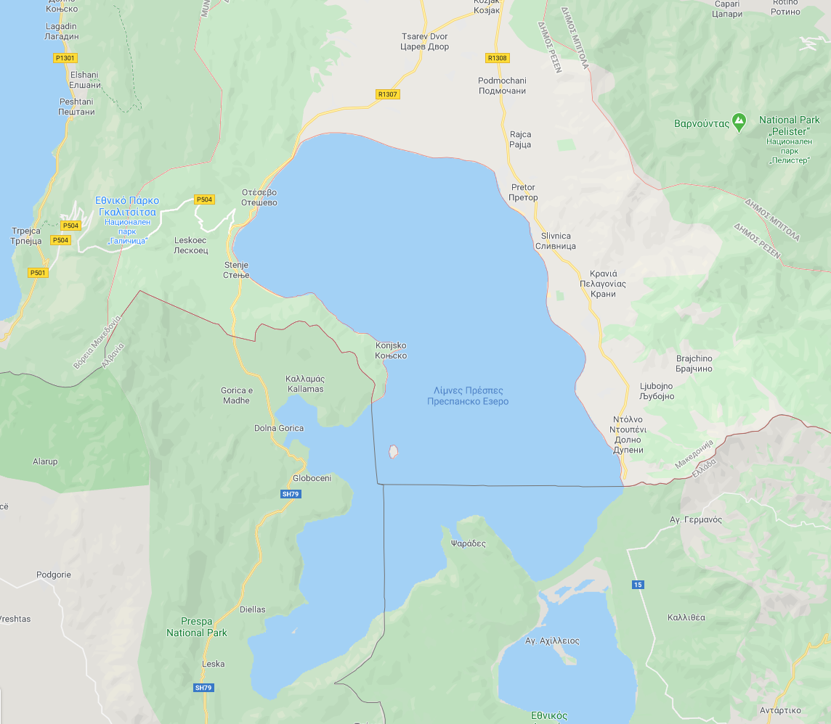
Figure 5: The village of Stenje in Resen (Source: Google Maps)
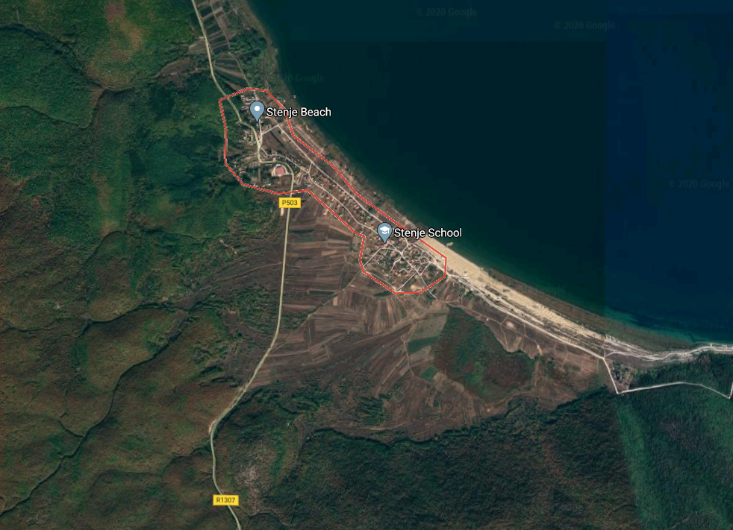
Figure 6: The village of Stenje in Resen (Source: Google Maps)

The City Hall of Resen is both the start and endpoint of the second route, where the charging of the electric vehicles is feasible. The second route drives to the destination of Evla and Bolno. Evla (North-Macedonian: Евла) is a village in Resen Municipality in North-Macedonia. Located in the northern part of the municipality, it is just under 5 km from the municipal center of Resen. It has 106 residents. Bolno (North-Macedonian: Болно) is a village in the Resen Municipality of North-Macedonia, near the mountain of Galičica. Located under 4 kilometres east of the municipal centre of Resen, the village has 237 residents. It is also home to a football club, FK Ilinden. Figures 7 and 8 show the location of Evla and Bolno villages.

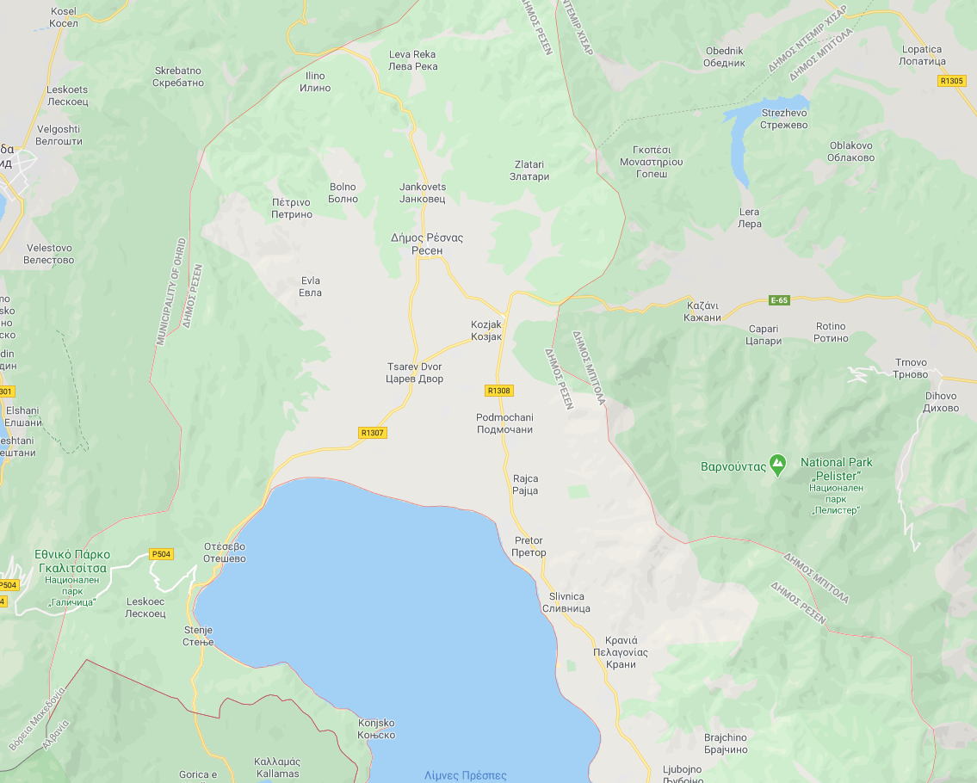
Figure 7: Evla and Bolno villages in Resen (Source: Google Maps)
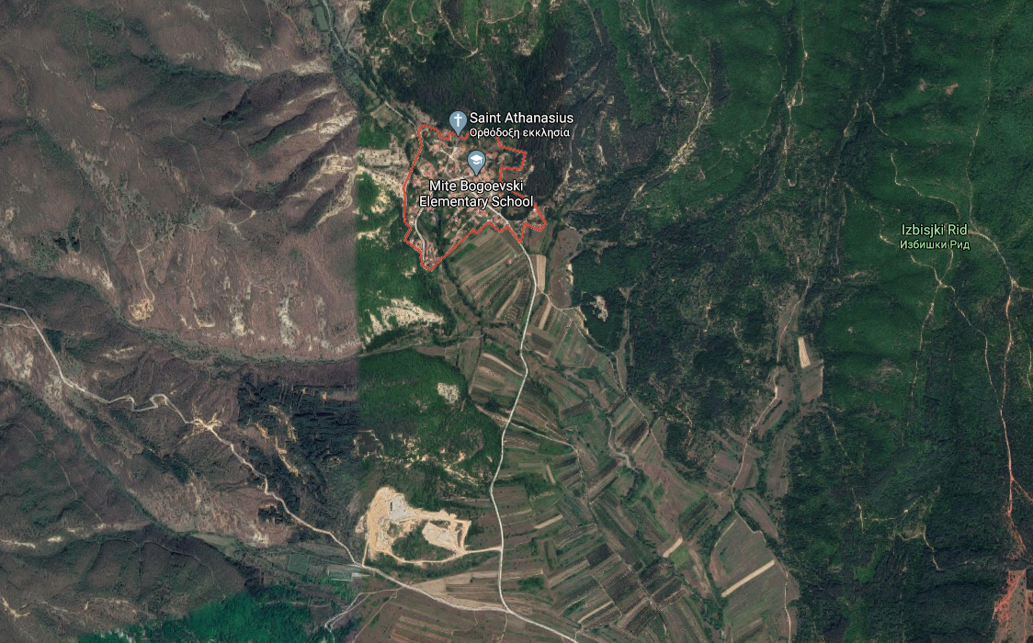
Figure 8: Evla and Bolno villages in Resen (Source: Google Maps)
City Hall is both the start and endpoint of the third route, where the charging of the electric vehicles is feasible. The third route drives to the destination of village Gorno Krushje. Gorno Krušje (North-Macedonian: Горно Крушје), or simply Krušje, is a village in northern Resen Municipality, Republic of Macedonia, located roughly 7.7 kilometres from the municipal center of Resen. The village has 107 residents as of the most recent census in 2002. Figures 9 and 10 show the location of village Gorno Krushje in Resen.
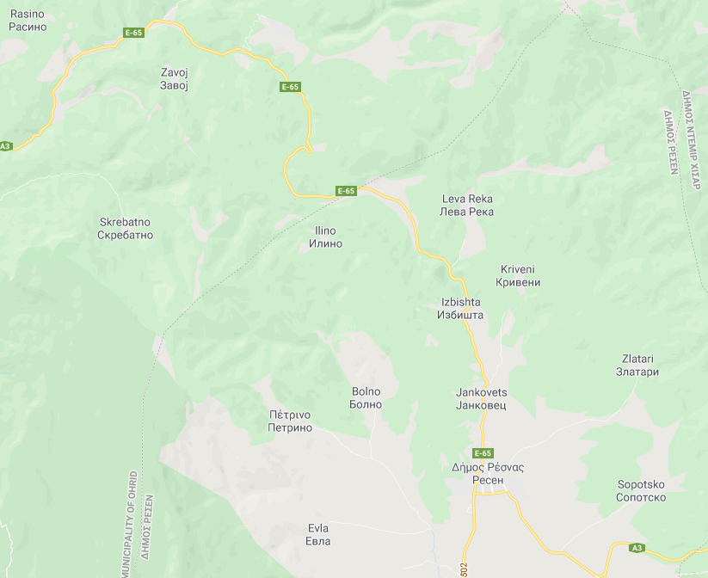
Gorno Krushje

Figure 9: Village Gorno Krushje in Resen (Source: Google Maps)
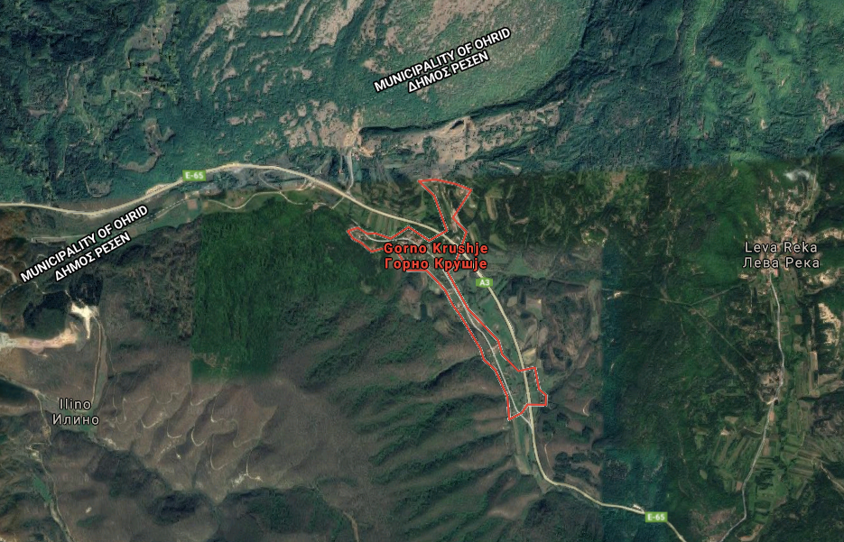
Figure 10: Gorno Krushje village on Resen (Source: Google Maps)

City Hall is both the start and endpoint of the fourth route, where the charging of the electric vehicles is feasible. The fourth route drives to the destination of village Sopotsko. Sopotsko (North-Macedonian: Сопотско), is a village in the Resen Municipality of the Republic of North-Macedonia. Sopotsko is roughly 5 kilometres from the municipal center of Resen. Figures 11 and 12 show the location of village Sopotsko in Resen.
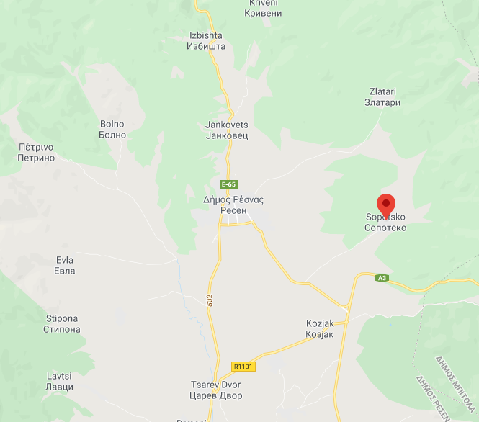
Figure 11: The village of Sopotsko in Resen (Source: Google Maps)

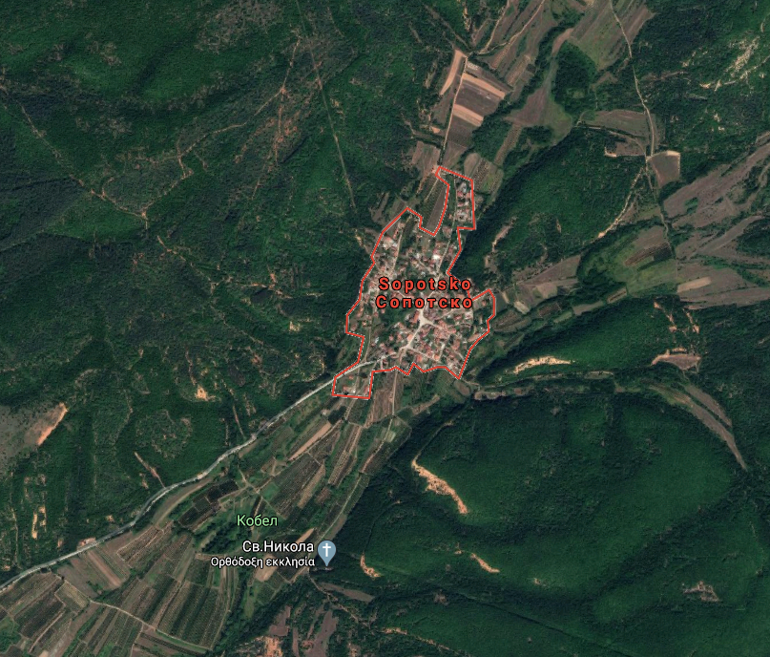
Figure 12: The village of Zlatari in Resen (Source: Google Maps)

City Hall is both the start and endpoint of the fifth route, where the charging of the electric vehicles is feasible. The fifth route drives to the destination of village Zlatari. Zlatari (North-Macedonian: Златари) is a village in northern Resen Municipality in the Republic of Macedonia. It is located just over 5 kilometres north of the municipal center of Resen. Figures 13 and 14 show the location of village Zlatari in Resen.
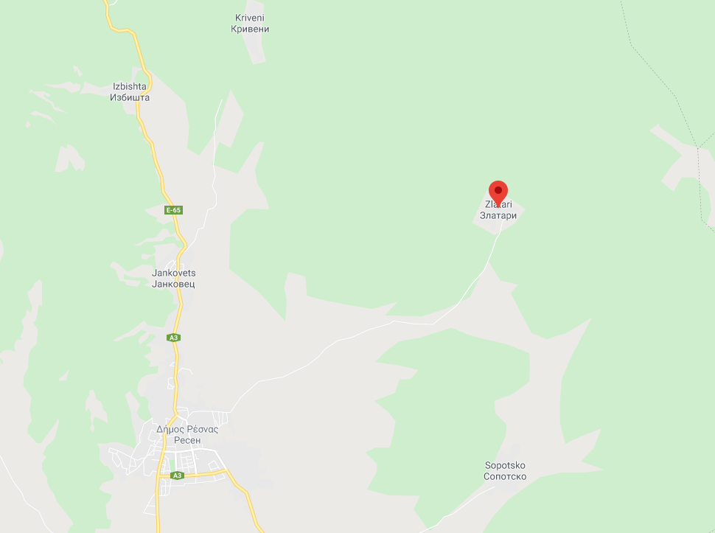
Figure 13: The village of Zlatari in Resen (Source: Google Maps)

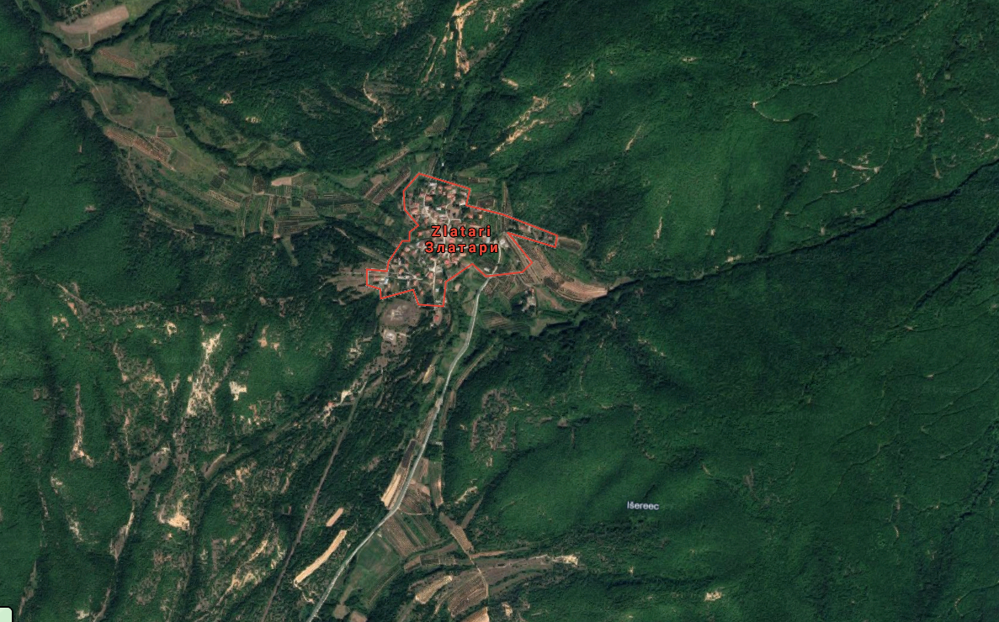
Figure 14: The village of Zlatari in Resen (Source: Google Maps)

City Hall is both the start and endpoint of the sixth route, where the charging of the electric vehicles is feasible. The sixth route drives to the destination of village Ezerani. Ezerani (North-Macedonian: Езерани) is a village in the Resen Municipality of North-Macedonia, on the northern shore of Lake Prespa. The village is 7 kilometres southwest of the municipal center of Resen. Figures 15 and 16 show the location of village Ezerani in Resen.
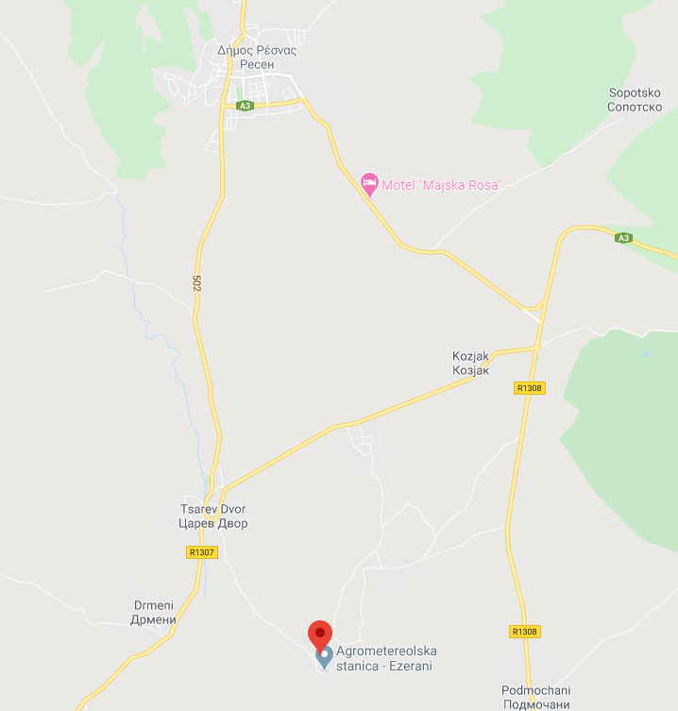
Figure 15: The village of Ezerani in Resen (Source: Google Maps)

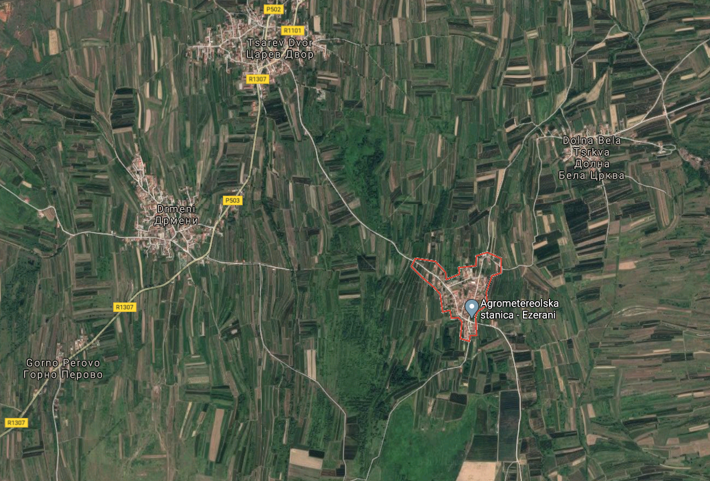
Figure 16: The village of Ezerani in Resen (Source: Google Maps)

City Hall is both the start and endpoint of the seventh route, where the charging of the electric vehicles is feasible. The seventh route drives to the destination of villages Dolno Dupeni and Brajchino. Dolno Dupeni (North-Macedonian: Долно Дупени) is a village in the Resen Municipality of North-Macedonia. Located on Lake Prespa, its beach runs to the border with Greece. Brajčino (North-Macedonian: Брајчино, [ˈbrajtʃinɔ]) is a village in the Resen Municipality of North-Macedonia, situated 6 kilometres from Lake Prespa, on Baba Mountain in Pelister National Park. The village is also located near the border with Greece. Brajčino's nature and old architecture draws both domestic and foreign tourists. Figures 17, 18 and 19 show the location of villages Dolno Dupeni and Brajchino in Resen.
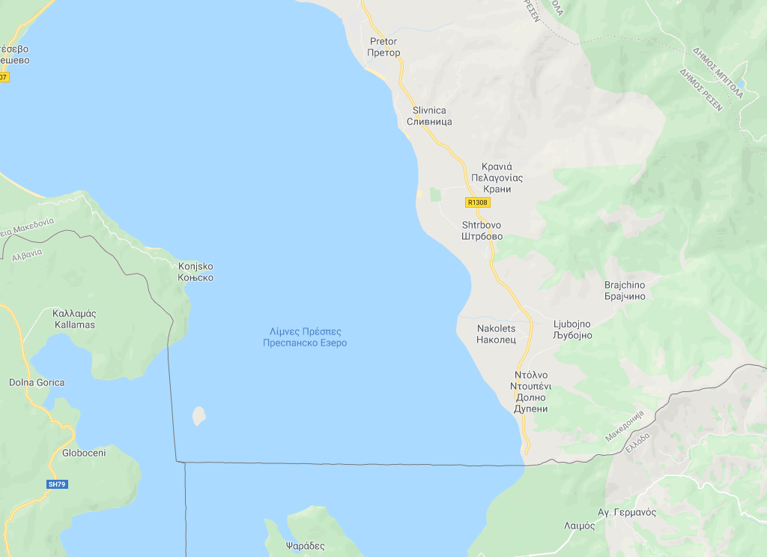
Figure 17: The villages of Dolno Dupeni and Brajchino in Resen (Source: Google Maps)

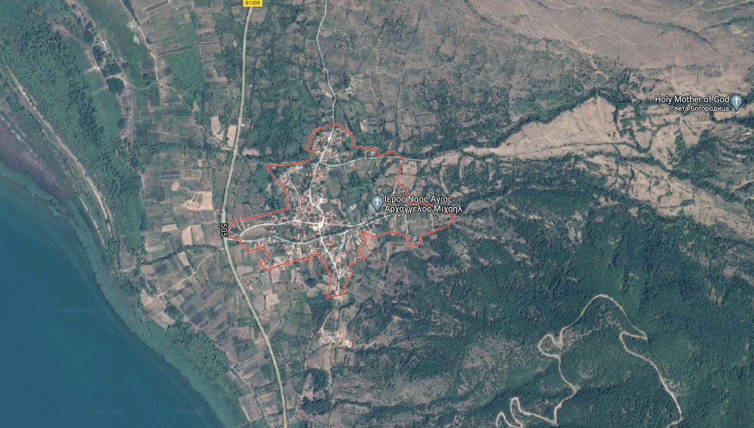
Figure 18: The village of Dolno Dupeni in Resen (Source: Google Maps)
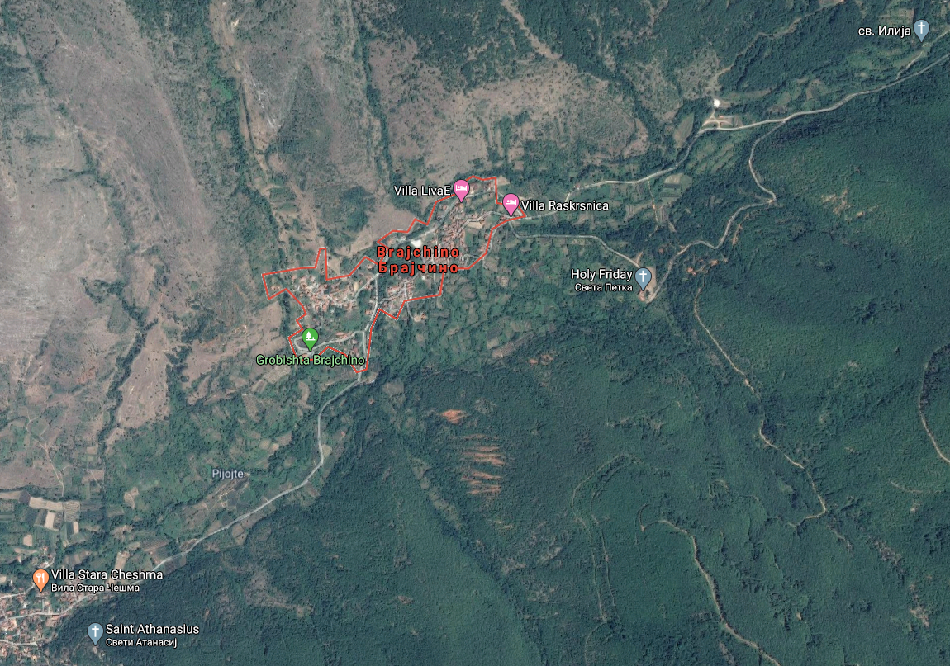
Figure 19: The village of Brajchino in Resen (Source: Google Maps)

E-minibus routing
In this section, the e-minibus routing is presented considering users’ preferences and traffic rules’ constraints.

Route 1 to Stenje
E-minibus routing was designed using Aimsun Next 8.4.0 Software considering traffic rules, i.e. allowed turns, double- or single-way roads, number of lanes and general road geometry’s constraints. Figures 20 and 21 show Resen’s center and the villages around it. The map shown in figure 21 was imported as a road network in Aimsun Next from Open Street Map.org.
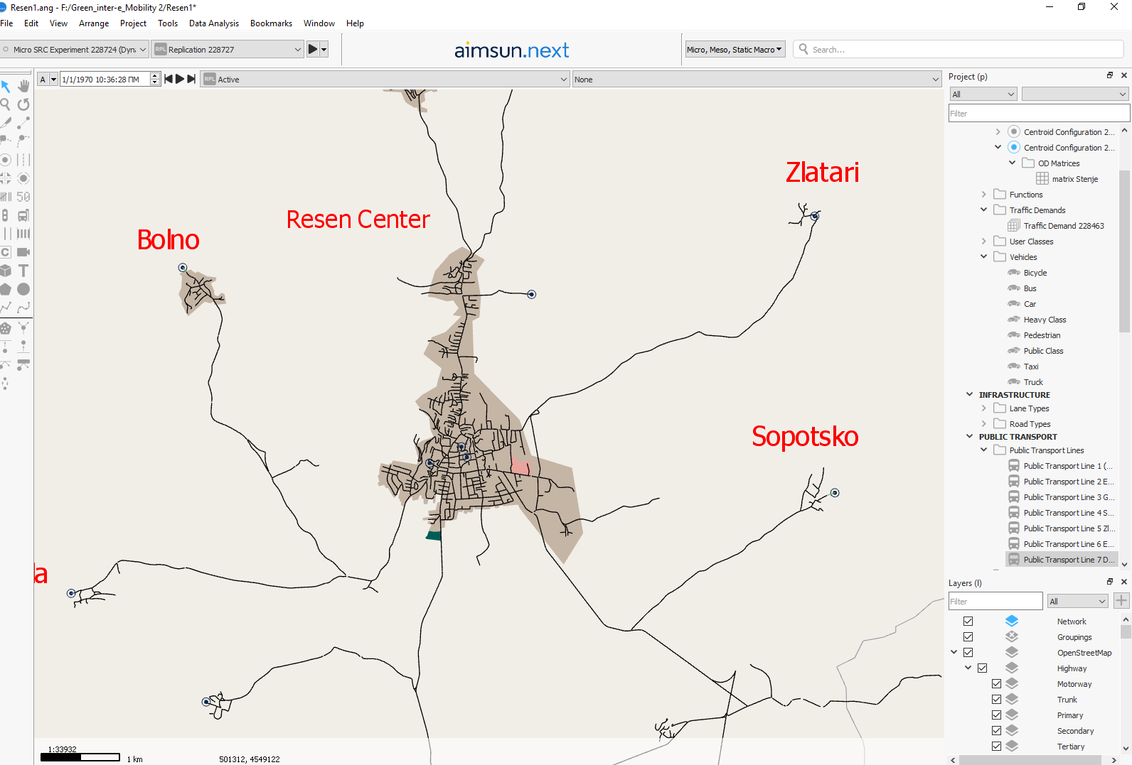
Figure 20: Resen center and the villages around it
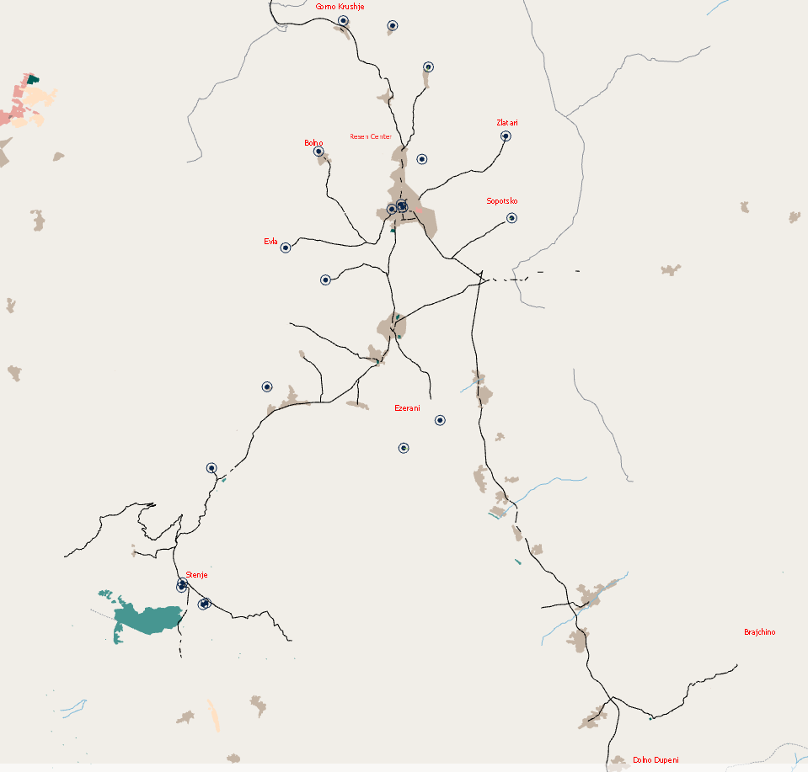
Figure 21: The whole map of Resen and the villages around it
After importing the map, including the whole center of Resen (and the villages around it), the best route to Stenje, route 1, was designed. A public transport line was created by selecting the appropriate road sections consecutively, according to data collected by Resen Municipality. Afterwards, the stops were defined in accordance with citizens’ needs. The stops were chosen in order to serve the majority of Resen’s citizens. Assuming that most mobility demands have an important location (hospitals, libraries, stadiums, markets etc.) as destination, the route serves most of daily citizens’ travels, as most important locations are either stops or “5-minutes-on-foot” away from the nearest stop. Four stops were designed, as follows:
- Stop 1: City Hall Resen (origin)
- Stop 2: Stenje School
- Stop 3: Stenje School (2)
- Stop 4: City Hall Resen (destination)
Figure 22 shows route 1, to Stenje (46.35 km). Figures 23 and 24 show parts of this route, City Hall in Resen and Stenje village, respectively.
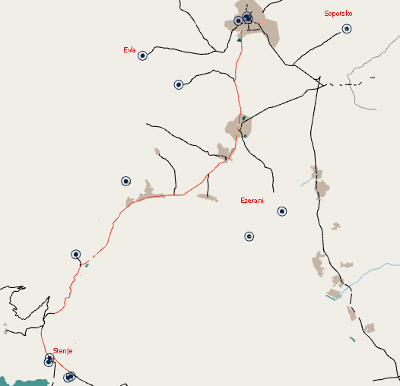
Figure 22: Route 1 to Stenje village

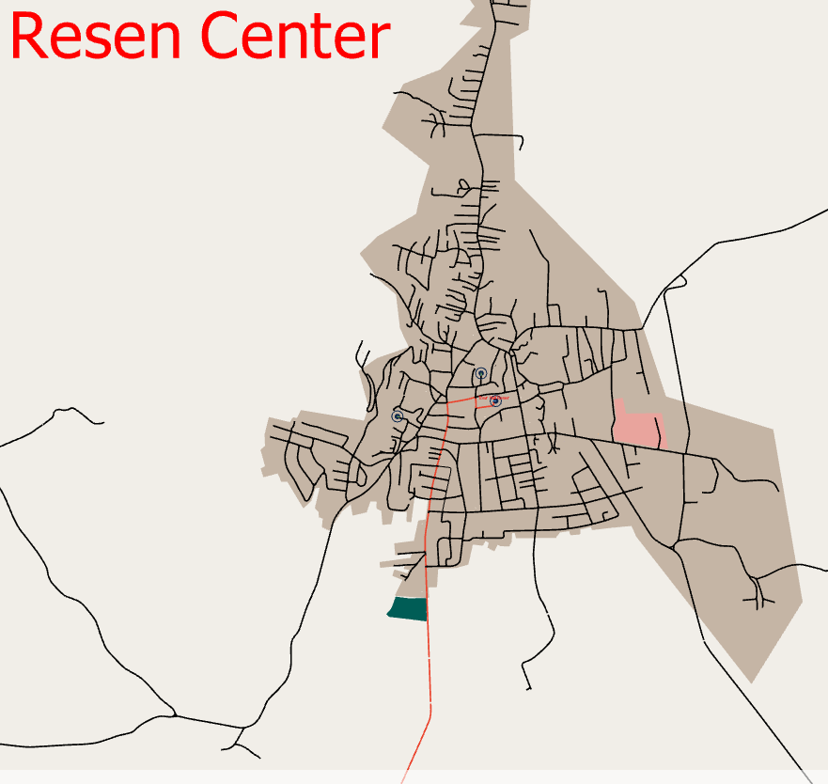
Figure 23: City Hall in Resen Center

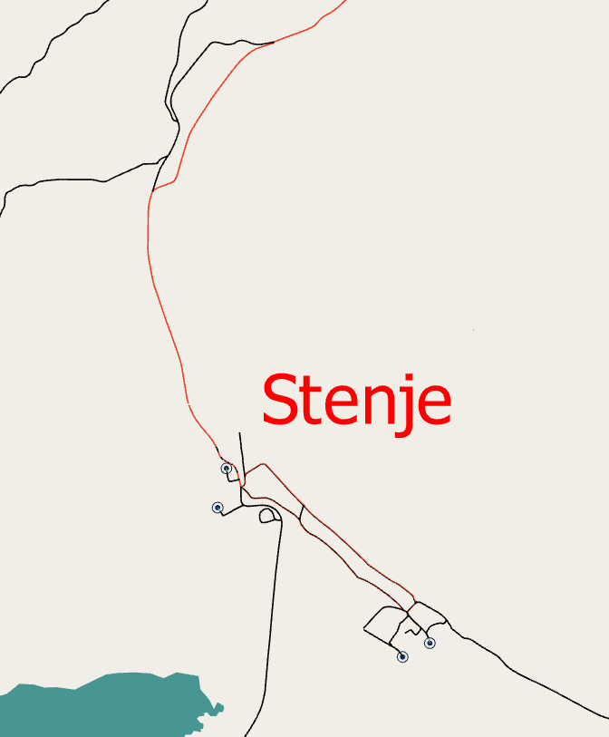
Figure 24: Stenje village
Figure 25 shows the route 1 to Stenje village and the intermediate stops. The stops are identified by green circles when they are imported in road sections on Aimsun and are selected for a specific public transport route. Figure 26 shows the three bus station types:
- Normal stop: Normal public transport stop occupies a fixed lane length. This is the simplest type of public transport stop.
- Bus bay stop: Bay stop is located at one side of the road segment, so that public transport vehicles stopped within the bay do not cause an obstruction within the segment.
- Terminal stop: Terminal stop is used to model public transport stations or bus parking. It has room for a limited number of public transport vehicles; capacity is defined as an attribute of the stop.
Normal stop is the type selected for the intermediate stops, and terminal stop is the type used for the last stop of the route. Two minutes were chosen as stop duration.
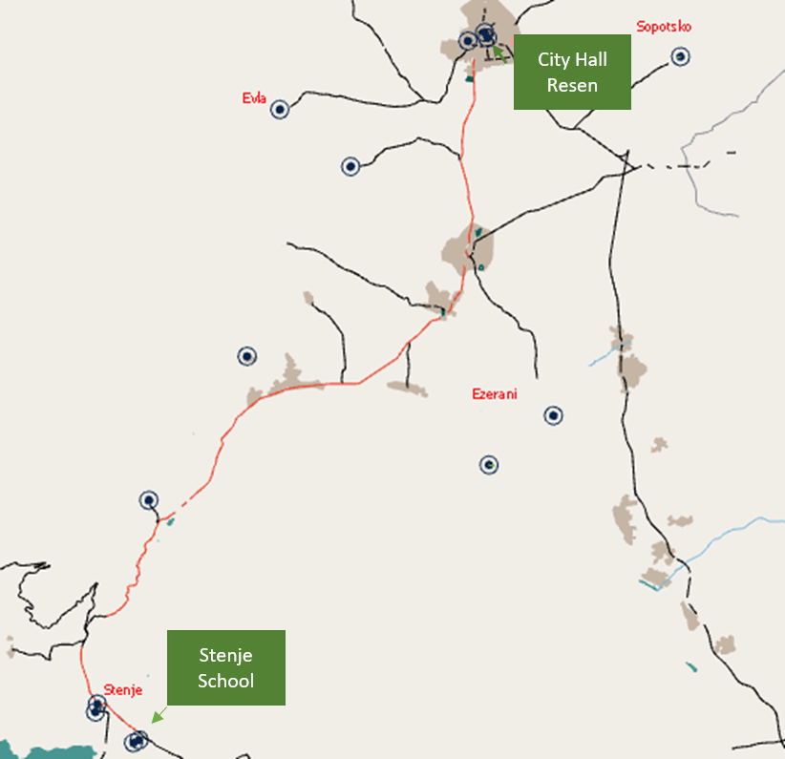
Figure 25: Route 1 to Stenje School and intermediate stops

Normal stops
Bus Bay stops
Terminal stops
Figure 26: The three types of stop

After designing the route and inserting the intermediate stops, a “Dynamic Traffic Scenario” considering this public transport route was run. “Dynamic Traffic Scenario” is an option in Aimsun software to make traffic simulations. Parameters such as public transport line, stops and traffic are included in the DTS, defining it, and affecting its final output. Using Aimsun, traffic was simulated on road sections, on which prevailing traffic conditions affect bus traffic. As there were no traffic data for these sections and for Resen Municipality generally, “Google Maps: Traffic” was used. Google Traffic informs about speed limits using a color code. This code, described below, was used to insert traffic flow values in Aimsun. Several traffic scenarios were run, until the observed speed per section approached the expected one, according to Google traffic data. Figure 27 illustrates the ways in which typical dynamic traffic scenarios serve City Hall Resen.
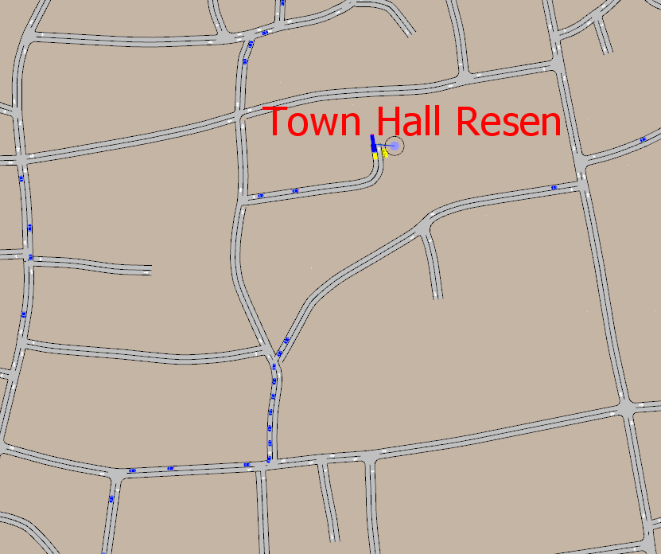
Figure 27: A typical traffic dynamic scenario on City Hall Resen

The colored lines representing traffic conditions on highways or streets refer to the speed at which one can travel on that road. The dreaded red lines on the map mean highway traffic is moving at less than 40.2 km per hour and could indicate an incident or congestion on that route. Yellow lines on the map indicate that traffic is moving faster, from 40.2 to 80.46 km per hour. Green lines on the traffic map indicate zipping along at 80.46 km per hour or more. Grey lines on the map indicate that no traffic information is available. The red-black line on the map indicates extremely slow or stopped traffic. Table 2 shows the Google Maps: Traffic color code about speed limits, while Figure 28 shows these limits in Resen center.

Table 2: The Google Maps: Traffic color code about speed limits
Color | Speed (km/h)
Red | <40
Yellow | 40-80
Green | >80
Grey | No traffic information available
Red-Black | Extremely slow/stopped traffic

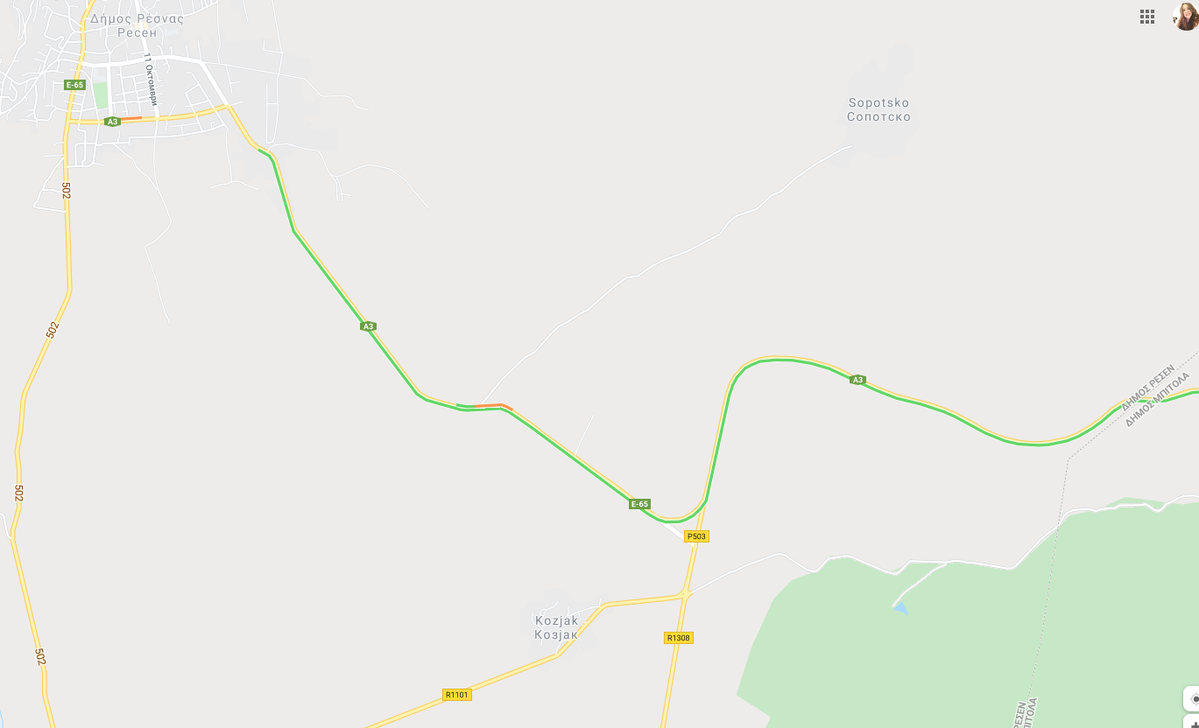
Figure 28: Speed limits in Resen center according to “Google Maps: Traffic”
Given the public transport line (route), its stops (origin, intermediate stops and destination) and a ran simulation in Aimsun, a position-time diagram was exported. This diagram illustrates the position of the bus as a function of time. Figure 29 shows the pattern of position and time for route 1 serving Stenje School, including the intermediate routes:
- Stop 1: City Hall Resen (origin)
- Stop 2: Stenje School
- Stop 3: Stenje School 2
- Stop 4: City Hall Resen (destination)

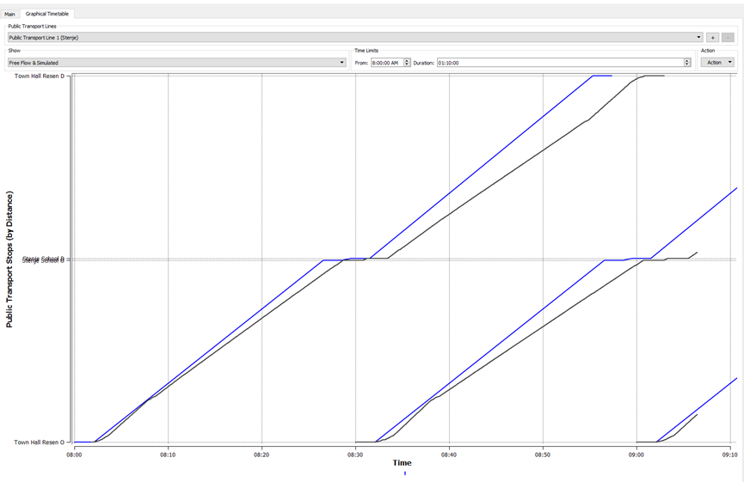
Figure 29: The position-time diagram for route 1 to Stenje School

In Figure 29 there are two lines, of different coloring. There is a blue line representing free flow conditions, and a black line representing real traffic conditions. For estimating travel conditions, simulations were performed using a dedicated software. The simulations were key for calculating the time for the bus to travel between stops, and to calculate overall trip time from origin to destination. The blue line stands for free flow conditions, namely road signage, road geometry and overall road traffic are not considered. These parameters exist in realistic traffic conditions causing significant latencies. Thus, the black line indicates more time for reaching the destination than the blue line. On the other hand, Aimsun simulation considered bus accelerations and decelerations after and before stops, road geometry, traffic signaling and rules, and traffic in the network, making the simulation realistic.
In Figure 29 there is a blue line (free flow conditions) and a black line (real traffic conditions). Blue lines correspond to free flow and start every 30 minutes in order to compare free flow with bus position on the route relative to time during simulation. The simulation was crucial for calculating the time for the bus to travel between stops, and to calculate overall time (from origin to destination). Free flow was not realistic as it assumes maximum speed for the whole trip. On the other hand, Aimsun simulation considered bus accelerations and decelerations after and before stops, road geometry, traffic signaling and rules, and other vehicles in the network. Black lines differ from blue lines, as the black ones represent the simulated (realistic) scenario. Thus, it is possible to compare free flow with simulated conditions, not only with respect to time, but also speed (slope of time-position figure). The simulation started at 8:00 and there is a deviation from free-flow line. In particular, the simulation starts at 8:00 and ends at 09:03 (duration=1 hour and 3 minutes), while in free flow conditions the bus starts at 8:00 and ends at 08:58 (duration=58 minutes).
It is considered that the minibus always follows the same route (to Stenje) with the same start (Town Hall) and the same end (Town Hall), without stopping for charging or for starting another route. This assumption was considered in simulations to calculate the average duration of route 1, considering stop, road geometry, signaling and traffic conditions.

Route 2 to Evla and Bolno villages
After importing the map (see Figure 21), including the whole region of Resen’s Center and the villages around it, the best route to Evla and Bolno villages, route 2, was designed. A public transport line was created by selecting the appropriate road sections consecutively, according to data collected by Resen Municipality. Afterwards, the stops were defined, in accordance with citizens’ needs. Four stops were designed, as follows:
- Stop 1: City Hall Resen (origin)
- Stop 2: Stenje School
- Stop 3: Stenje School (2)
- Stop 4: City Hall Resen (destination)
Figure 30 shows route 2 (21.57 km), to Evla and Bolno villages. Figures 31 and 32 show parts of this route, City Hall in Resen and Evla village, respectively.

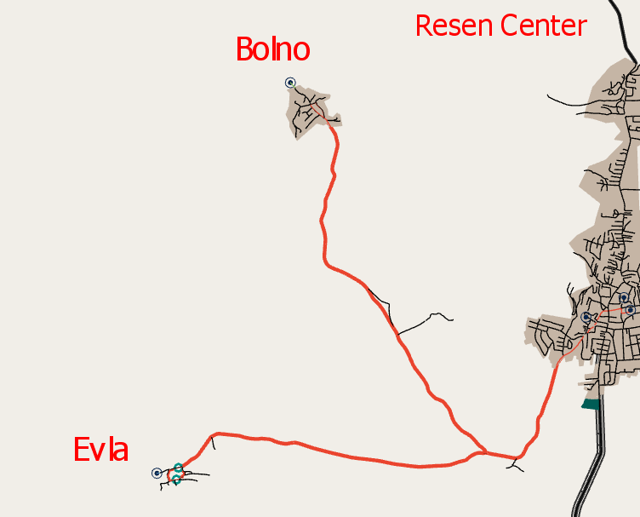

Figure 30: Route 2 to Evla and Bolno villages

Figure 31: City Hall in Resen Center

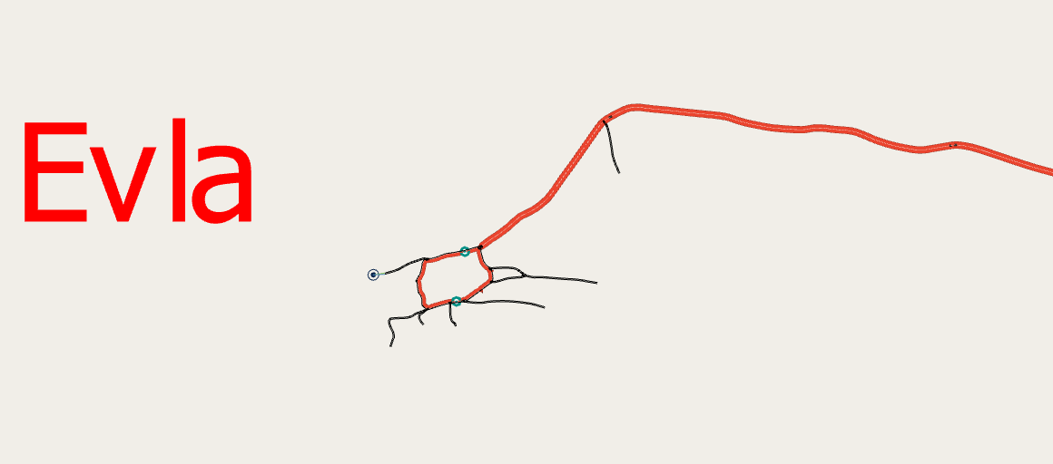
Figure 32: Evla village
Figure 33 shows the route to Evla and Bolno villages and the intermediate stops. The stops are identified by green circles when they are imported in road sections in Aimsun, and are selected for a specific public transport route. Two minutes were chosen as stop duration.

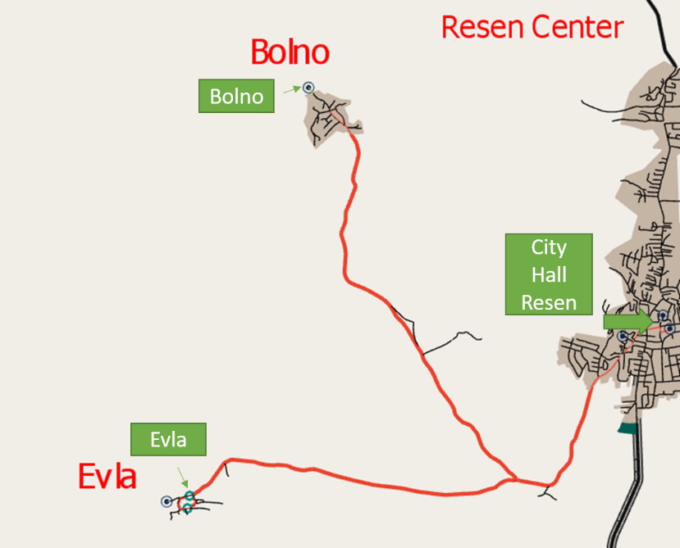
Figure 33: Route 2 to Evla and Bolno villages and the intermediate stops
After designing the route and inserting the intermediate stops, a “Dynamic Traffic Scenario (DTS)” considering this public transport route was run. As there were no traffic data for the road sections included in the DTS, and for Resen Municipality generally, “Google Maps: Traffic” was used. Google Traffic informs about speed limits using a color code. This code, described above, was used to insert traffic flow values in Aimsun. Figure 34 shows a typical dynamic traffic scenario on City Hall Resen.
Figure 34: A typical traffic dynamic scenario on City Hall Resen
Given the public transport line (route), its stops (origin, intermediate stops and destination) and a ran simulation in Aimsun, a position-time diagram was exported. This diagram illustrates the position of the bus as a function of time. Figure 35 shows the pattern of position and time for route 2 to Evla and Bolno villages, including the intermediate routes:
- Stop 1: City Hall Resen (origin)
- Stop 2: Evla
- Stop 3: Evla 2
- Stop 3: Bolno
- Stop 4: Bolno 2
- Stop 4: City Hall Resen (destination)
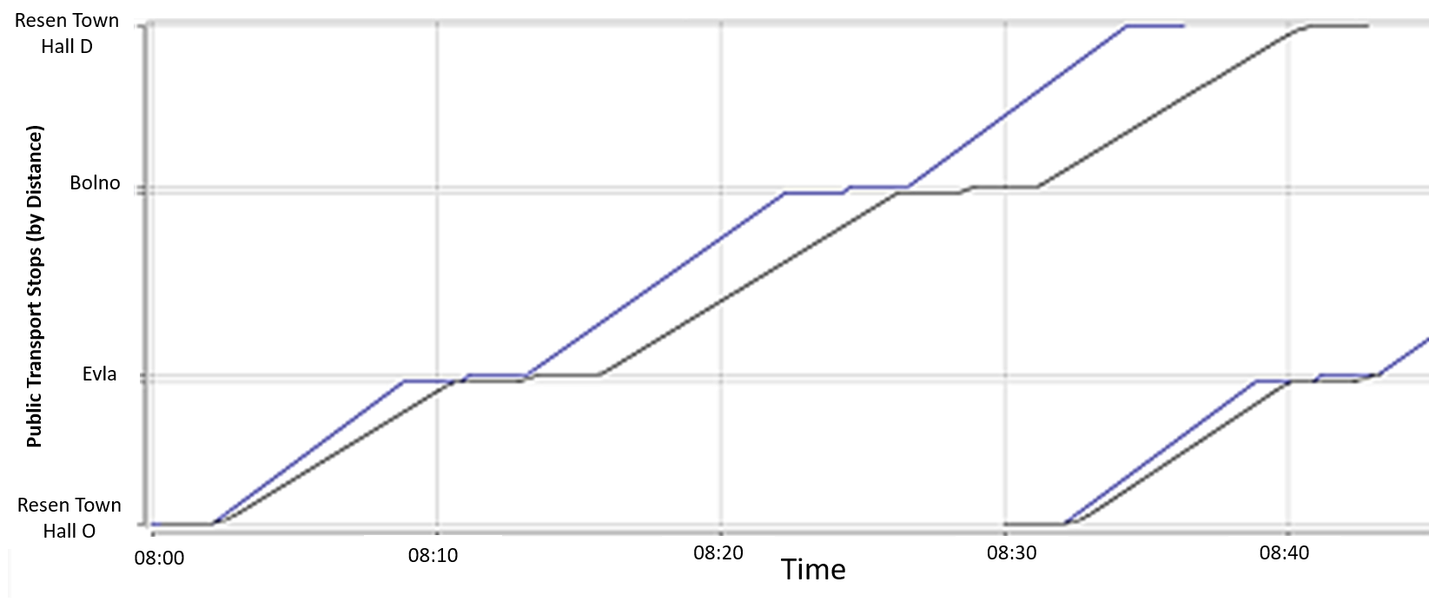
Figure 35: The position-time diagram for route 2 to Evla and Bolno villages
In Figure 35 there are two lines, of different coloring. There is a blue line representing free flow conditions, and a black line representing real traffic conditions. For estimating travel conditions, simulations were performed using a dedicated software. The simulations were key for calculating the time for the bus to travel between stops, and to calculate overall trip time from origin to destination. The blue line stands for free flow conditions, namely road signage, road geometry and overall road traffic are not considered. These parameters exist in realistic traffic conditions causing significant latencies. Thus, the black line indicates more time for reaching the destination than the blue line. On the other hand, Aimsun simulation considered bus accelerations and decelerations after and before stops, road geometry, traffic signaling and rules, and traffic in the network, making the simulation realistic.
In Figure 35, there is a blue line (free flow conditions) and a black line (real traffic conditions). Blue lines correspond to free flow and start every 30 minutes in order to compare free flow with bus position on the route relative to time during simulation. The simulation was crucial in order to calculate the time the bus needs to travel from stop to stop and to calculate overall time (from origin to destination). Free flow was not realistic as it assumes maximum speed for the whole trip. On the other hand, Aimsun simulation considered bus accelerations and decelerations after and before stops, road geometry, traffic signaling and rules, and other vehicles in the network. Black lines differ from blue lines, with the black ones representing the simulated (realistic) scenario. This calculation was necessary in order to compare free flow with simulated conditions, not only relative to time, but also relative to speed (slope of time-position figure). The simulation started at 8:00, and there is a deviation from free-flow line. In particular, the simulation starts at 8:00 and ends at 08:43 (duration=43 minutes), while in free flow conditions the bus starts at 8:00 and ends at 08:36 (duration=36 minutes).
It is considered that the minibus always follows the same route (to Evla and Bolno) with the same start (Town Hall) and the same end (Town Hall), without stopping for charging or for starting another route. This assumption was considered in simulations to calculate the average duration of route 2, considering stop, road geometry, signaling and traffic conditions.

Route 3 to village Gorno Krushje
After importing the map (see Figure 21), including the whole region of Resen’s Center and the villages around it, the best route to Gorno Krushje village, route 3, was designed. A public transport line was created by selecting the appropriate road sections consecutively, according to data collected by Resen Municipality. Afterwards, the stops were defined, in accordance with citizens’ needs. Four stops were designed, as follows:
- Stop 1: City Hall Resen (origin)
- Stop 2: Gorno Krushje
- Stop 3: Gorno Krushje (2)
- Stop 4: City Hall Resen (destination)
Figure 36 shows route 3 (18.95 km), to Bolno Krushje village. Figures 37 and 38 show parts of this route, City Hall in Resen and Gorno krushje village, respectively.
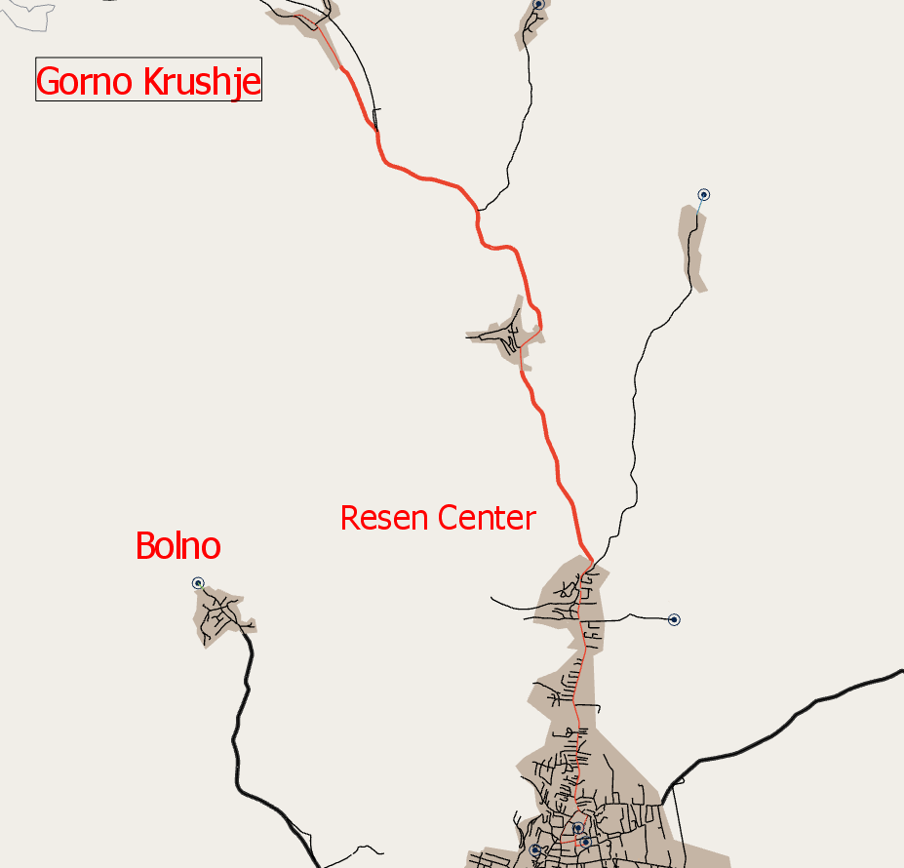
Figure 36: Route 3 to Gorno Krushje village

Figure 37: City Hall in Resen Center

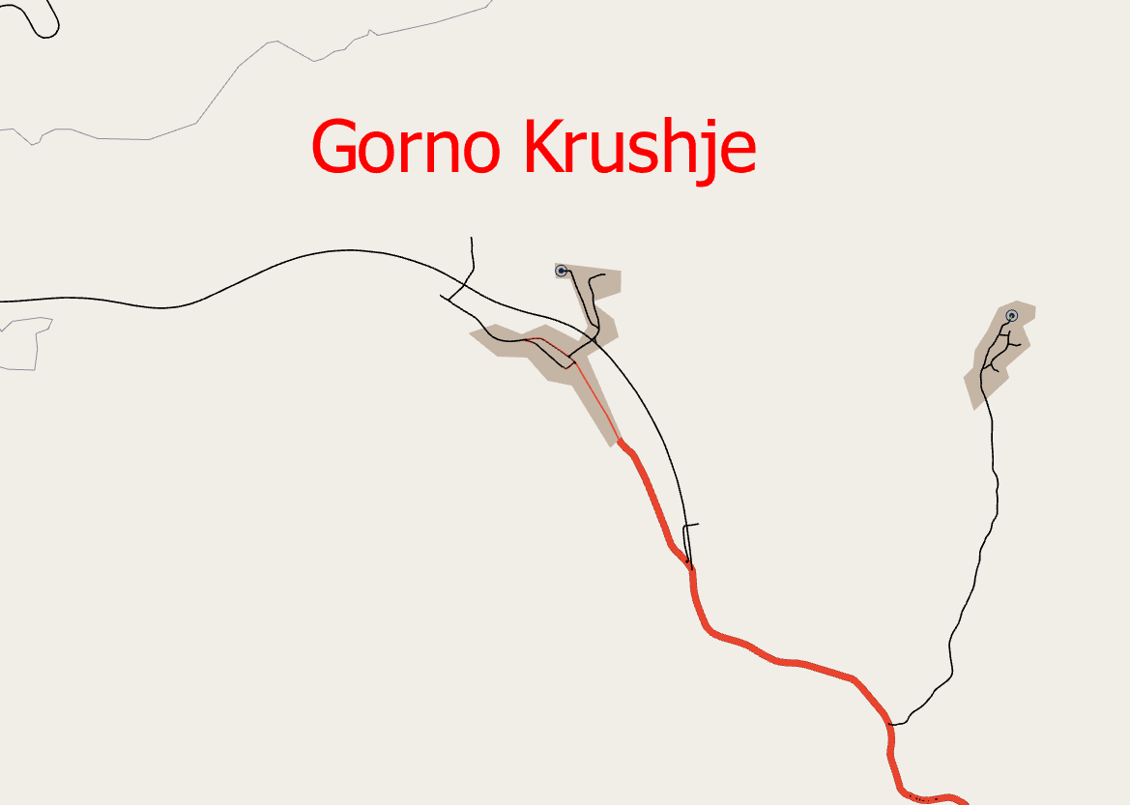
Figure 38: Gorno Krushje village
Figure 39 shows the route to Gorno Krushje village and the intermediate stops. The stops are identified with green circles when they are imported in road sections on Aimsun and are selected for a specific public transport route. Two minutes were chosen as stop duration.
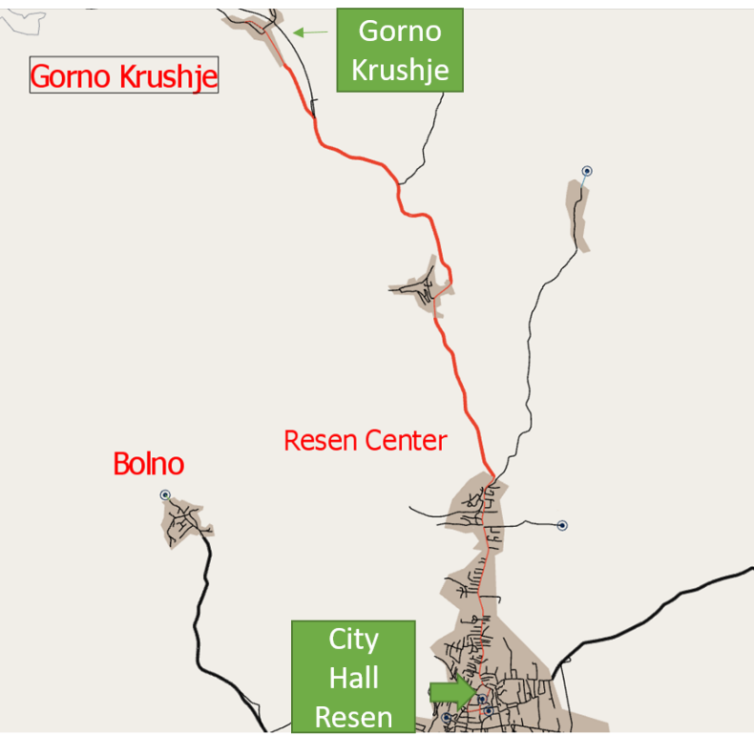
Figure 39: Route 3 to Gorno Krushje and intermediate stops
After designing the route and inserting the intermediate stops, a “Dynamic Traffic Scenario (DTS)” considering this public transport route was run. As there were no traffic data for the road sections included in the DTS, and for Bitola Municipality generally, “Google Maps: Traffic” was used. Google Traffic informs about speed limits using a color code. This code, described above, was used to insert traffic flow values in Aimsun. Figure 40 shows a typical dynamic traffic scenario on City Hall Resen.
Figure 40: A typical traffic dynamic scenario in City Hall Resen

Given the public transport line (route), its stops (origin, intermediate stops and destination) and a ran simulation in Aimsun, a position-time diagram was exported. This diagram illustrates the position of the bus as a function of time. Figure 41 shows the pattern of position and time for route 3 to Gorno Krushje village, including the intermediate routes:
- Stop 1: City Hall Resen (origin)
- Stop 2: Gorno Krushje
- Stop 3: Gorno Krushje 2
- Stop 4: City Hall Resen (destination)

Figure 41: The position-time diagram for route 3 to Gorno Krushje village
In Figure 41 there are two lines, of different coloring. There is a blue line representing free flow conditions, and a black line representing real traffic conditions. For estimating travel conditions, simulations were performed using a dedicated software. The simulations were key for calculating the time for the bus to travel between stops, and to calculate overall trip time from origin to destination. The blue line stands for free flow conditions, namely road signage, road geometry and overall road traffic are not considered. These parameters exist in realistic traffic conditions causing significant latencies. Thus, the black line indicates more time for reaching the destination than the blue line. On the other hand, Aimsun simulation considered bus accelerations and decelerations after and before stops, road geometry, traffic signaling and rules, and traffic in the network, making the simulation realistic.
In Figure 41 there is a blue line (free flow conditions) and a black line (real traffic conditions). Blue lines correspond to free flow and start every 30 minutes in order to compare free flow with bus position on the route relatively to time during simulation. The simulation was crucial in order to calculate the time the bus needs to travel from stop to stop and to calculate overall time (from origin to destination). Free flow was not realistic as it assumes maximum speed for the whole trip. On the other hand, Aimsun simulation considered bus accelerations and decelerations after and before stops, road geometry, traffic signaling and rules and other vehicles in the network. Black lines differ from blue lines, with the black ones representing the simulated (realistic) scenario. This allowed comparing free flow with simulated conditions, not only relative to time, but also speed (slope of time-position figure). The simulation started at 8:00 and there is a deviation from free-flow line. In particular, the simulation starts at 8:00 and ends at 08:31 (duration=31 minutes), while in free flow conditions the bus starts at 8:00 and ends at 08:26 (duration=26 minutes).
It is considered that the minibus always follows the same route (to Gorno Krushje) with the same start (Town Hall) and the same end (Town Hall), without stopping for charging or for starting another route. This assumption was considered in simulations to calculate the average duration of route 3, considering stop, road geometry, signaling and traffic conditions.

Route 4 to village Sopotsko
After importing the map (see Figure 21), including the whole region of Resen’s Center and the villages around it, the best route to Sopotsko village, route 4, was designed. A public transport line was created by selecting the appropriate road sections consecutively, according to data collected by Resen Municipality. Afterwards, the stops were defined, in accordance with citizens’ needs. Four stops were designed, as follows:
- Stop 1: City Hall Resen (origin)
- Stop 2: Sopotsko
- Stop 3: Sopotsko (2)
- Stop 4: City Hall Resen (destination)
Figure 42 shows route 4 (13.42 km), to Sopotsko village. Figures 43 and 44 show parts of this route, City Hall in Resen and Sopotsko village, respectively.

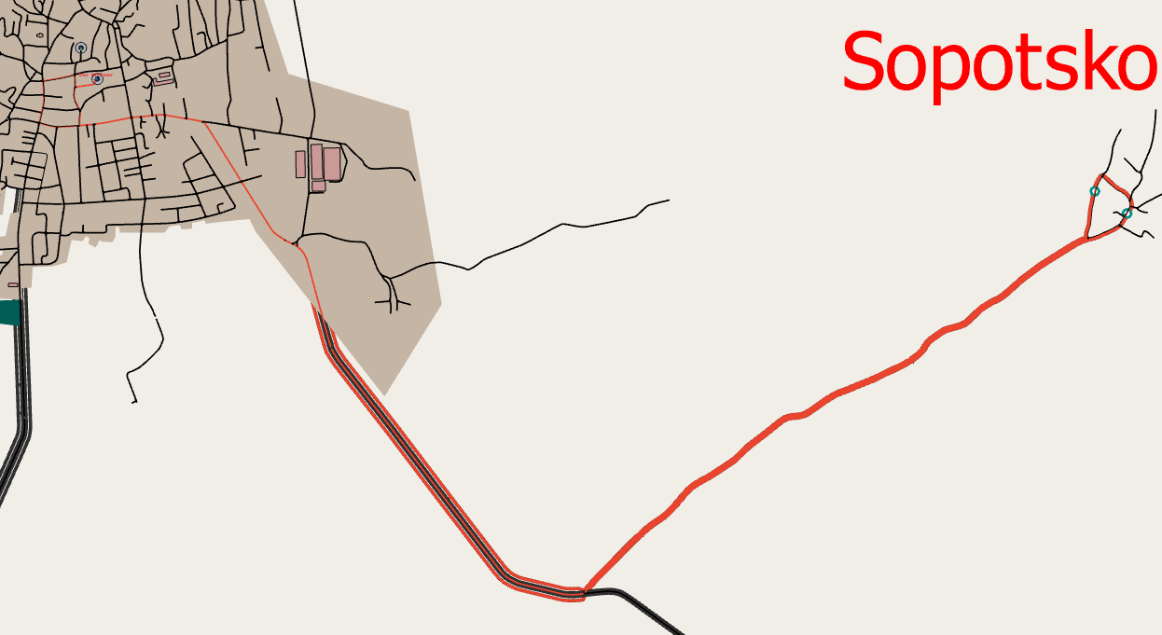
Figure 42: Route 4 to Sopotsko village

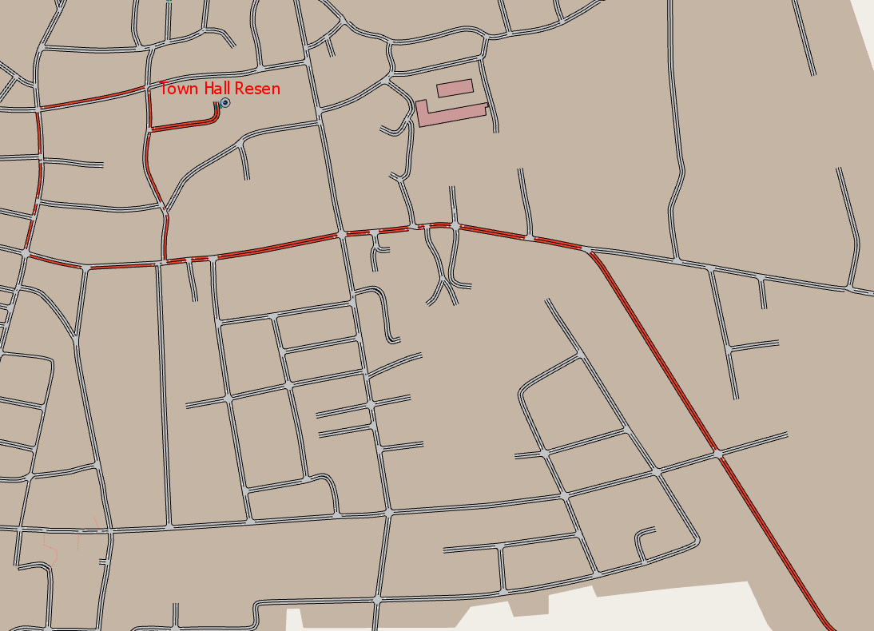
Figure 43: City Hall in Resen Center

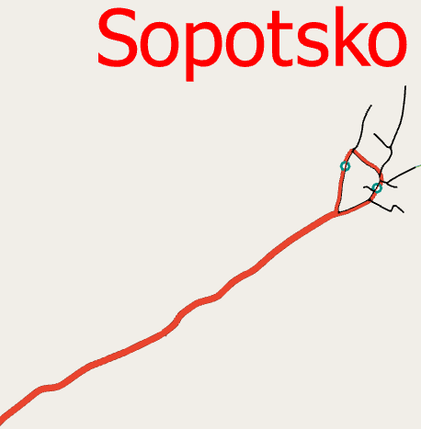
Figure 44: Sopotsko village
Figure 45 shows the route to Sopotsko village and the intermediate stops. The stops are identified with green circles when they are imported in road sections on Aimsun and are selected for a specific public transport route. Two minutes were chosen as stop duration.

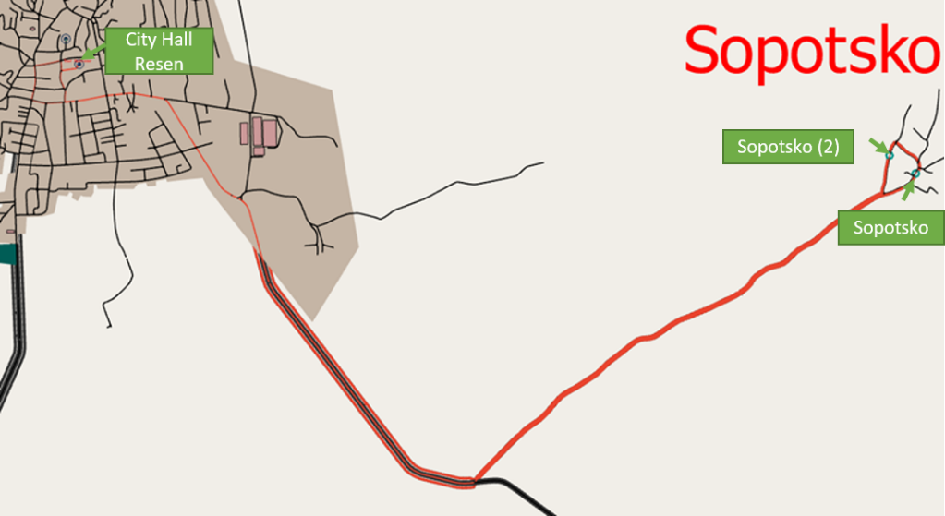
Figure 45: Route 4 to Sopotsko village and the intermediate stops

After designing the route and inserting the intermediate stops, a “Dynamic Traffic Scenario (DTS)” considering this public transport route was run. As there were no traffic data for the road sections included in the DTS, and for Bitola Municipality generally, “Google Maps: Traffic” was used. Google Traffic informs about speed limits using a color code. This code, described above, was used to insert traffic flow values in Aimsun. Figure 46 shows a typical dynamic traffic scenario on City Hall Resen.
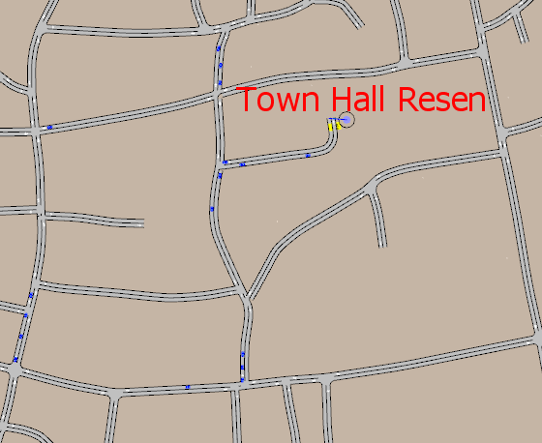
Figure 46: Typical traffic dynamic scenario in City Hall Resen
Given the public transport line (route), its stops (origin, intermediate stops and destination) and a ran simulation in Aimsun, a position-time diagram was exported. This diagram illustrates the position of the bus as a function of time. Figure 47 shows the pattern of position and time for route 4 to Sopotsko village, including the intermediate routes:
- Stop 1: City Hall Resen (origin)
- Stop 2: Sopotsko
- Stop 3: Sopotsko (2)
- Stop 4: City Hall Resen (destination)
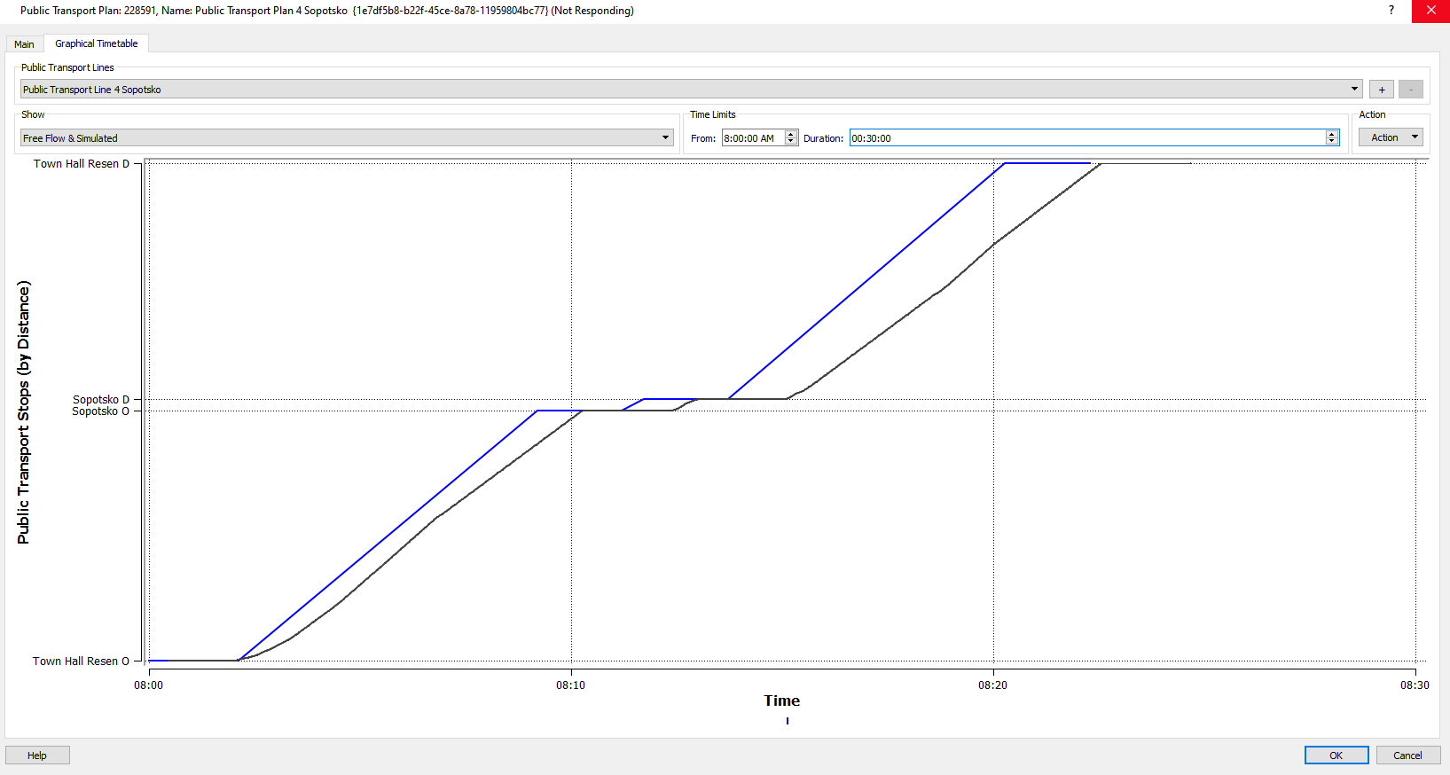
Figure 47: The position-time diagram for route 4 to Sopotsko village
In Figure 47 there are two lines, of different coloring. There is a blue line representing free flow conditions, and a black line representing real traffic conditions. For estimating travel conditions, simulations were performed using a dedicated software. The simulations were key for calculating the time for the bus to travel between stops, and to calculate overall trip time from origin to destination. The blue line stands for free flow conditions, namely road signage, road geometry and overall road traffic are not considered. These parameters exist in realistic traffic conditions causing significant latencies. Thus, the black line indicates more time for reaching the destination than the blue line. On the other hand, Aimsun simulation considered bus accelerations and decelerations after and before stops, road geometry, traffic signaling and rules, and traffic in the network, making the simulation realistic.

In Figure 47, there is a blue line (free flow conditions) and a black line (real traffic conditions). Blue lines correspond to free flow and start every 30 minutes in order to compare free flow with bus position on the route relatively to time during simulation. The simulation was crucial in order to calculate the time the bus needs to travel from stop to stop and to calculate overall time (from origin to destination). Free flow was not realistic as it assumes maximum speed for the whole trip. On the other hand, Aimsun simulation considered bus accelerations and decelerations after and before stops, road geometry, traffic signaling and rules and other vehicles in the network. Black lines differ from blue lines, with the black ones representing the simulated (realistic) scenario. This was necessary in order to compare free flow with simulated conditions, not only relative to time, but also relative to speed (slope of time-position figure). The simulation started at 8:00 and there is a deviation from free-flow line. In particular, the simulation starts at 8:00 and ends at 08:24 (duration=24 minutes), while in free flow conditions the bus starts at 8:00 and ends at 08:22 (duration=22 minutes).
It is considered that the minibus always follows the same route (to Sopotsko) with the same start (Town Hall) and the same end (Town Hall), without stopping for charging or for starting another route. This assumption was considered in simulations to calculate the average duration of route 4, considering stop, road geometry, signaling and traffic conditions.

Route 5 to village Zlatari
After importing the map (see Figure 21), including the whole region of Resen’s Center and the villages around it, the best route to Zlatari village, route 5, was designed. A public transport line was created by selecting the appropriate road sections consecutively, according to data collected by Resen Municipality. Afterwards, the stops were defined, in accordance with citizens’ needs. Four stops were designed, as follows:
- Stop 1: City Hall Resen (origin)
- Stop 2: Zlatari
- Stop 3: Zlatari (2)
- Stop 4: City Hall Resen (destination)
Figure 48 shows route 5 (12.45 km), to Zlatari village. Figures 49 and 50 show parts of this route, City Hall in Resen and Zlatari village, respectively.

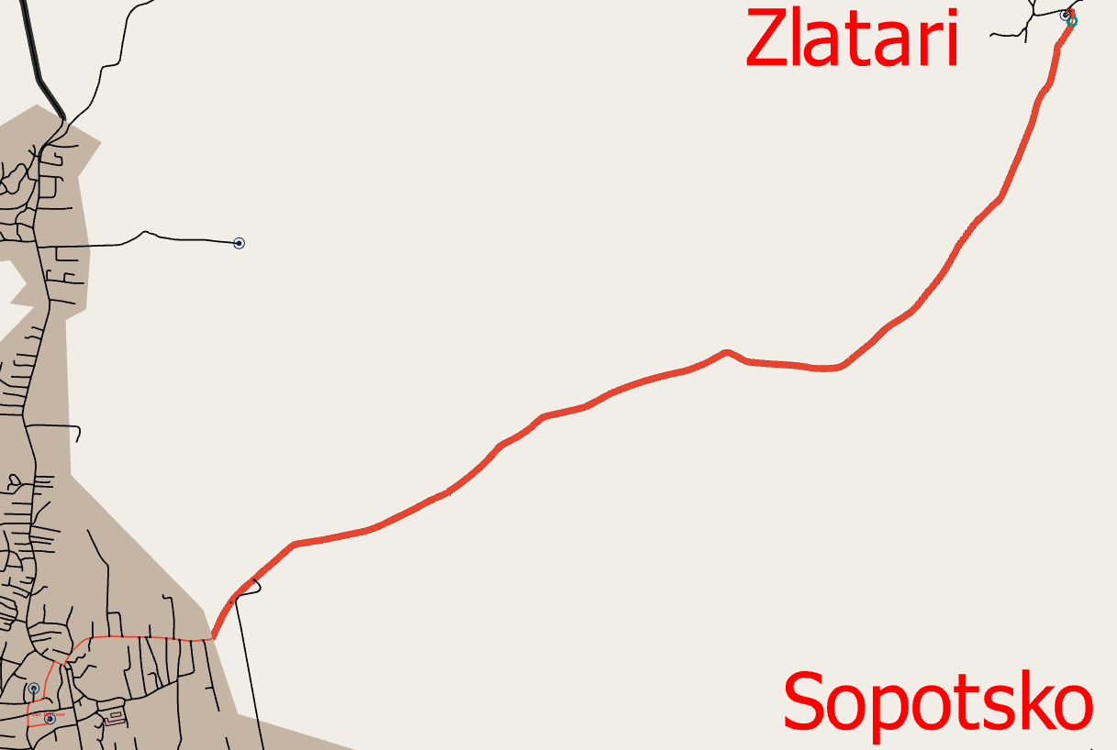
Figure 48: Route 5 to Zlatari village

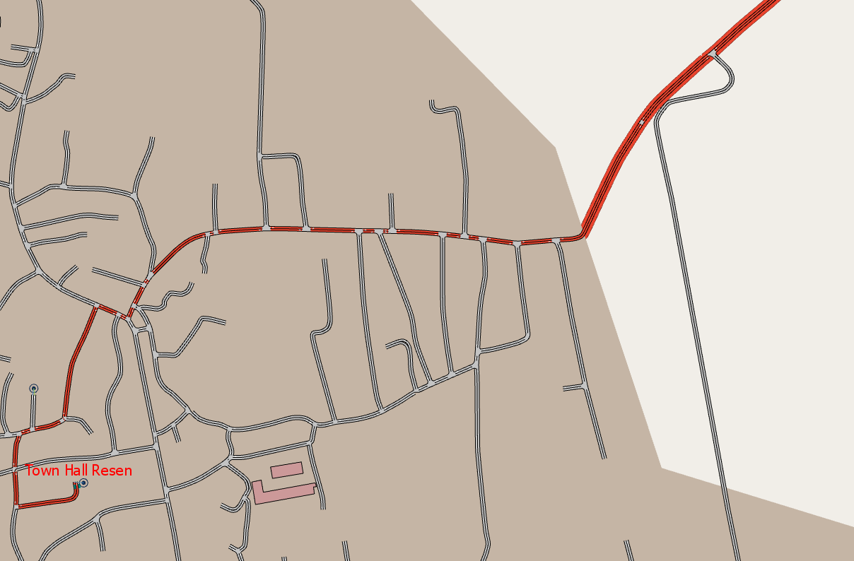
Figure 49: City Hall in Resen Center

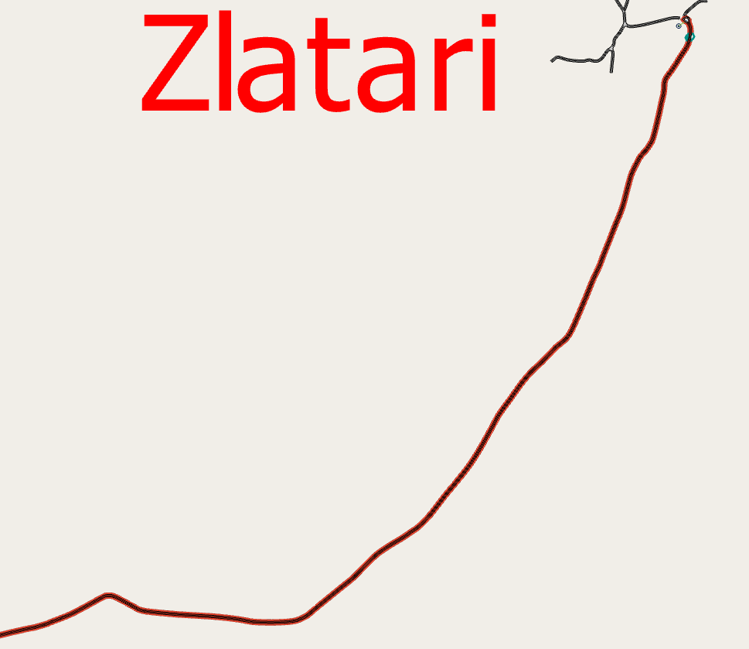
Figure 50: Zlatari village
Figure 51 shows the route to Zlatari village and the intermediate stops. The stops are identified with green circles when they are imported in road sections in Aimsun and are selected for a specific public transport route. Two minutes were chosen as stop duration.
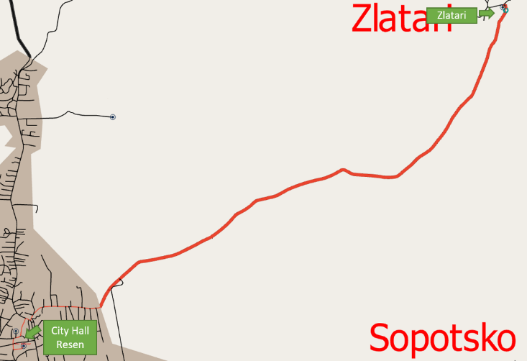
Figure 51: Route 5 to Zlatari village and intermediate stops

After designing the route and inserting the intermediate stops, a “Dynamic Traffic Scenario (DTS)” considering this public transport route was run. As there were no traffic data for the road sections included in the DTS, and for Bitola Municipality generally, “Google Maps: Traffic” was used. Google Traffic informs about speed limits using a color code. This code, described above, was used to insert traffic flow values in Aimsun. Figure 52 shows a typical dynamic traffic scenario on City Hall Resen.
Figure 52: A typical traffic dynamic scenario in City Hall Resen
Given the public transport line (route), its stops (origin, intermediate stops and destination) and a ran simulation in Aimsun, a position-time diagram was exported. This diagram illustrates the position of the bus as a function of time. Figure 53 shows the pattern of position and time for route 5 to Zlatari village, including the intermediate routes:
- Stop 1: City Hall Resen (origin)
- Stop 2: Zlatari
- Stop 3: Zlatari (2)
- Stop 4: City Hall Resen (destination)
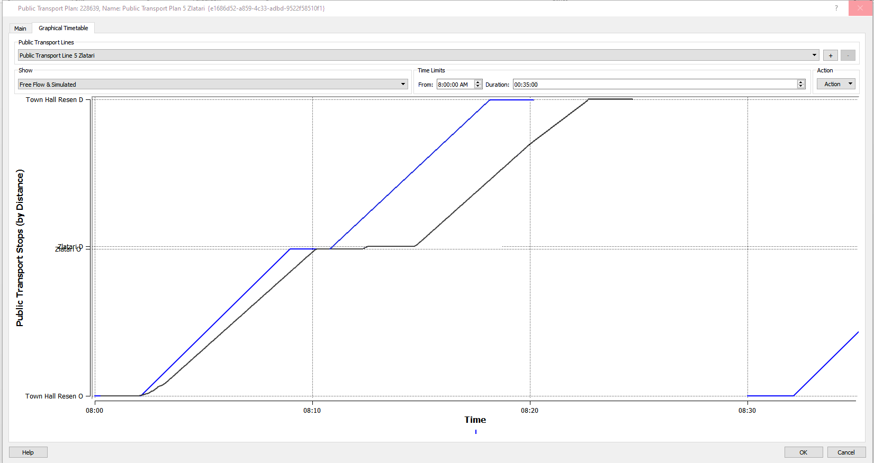
Figure 53: The position-time diagram for route 5 to Zlatari village

In Figure 53 there are two lines, of different coloring. There is a blue line representing free flow conditions, and a black line representing real traffic conditions. For estimating travel conditions, simulations were performed using a dedicated software. The simulations were key for calculating the time for the bus to travel between stops, and to calculate overall trip time from origin to destination. The blue line stands for free flow conditions, namely road signage, road geometry and overall road traffic are not considered. These parameters exist in realistic traffic conditions causing significant latencies. Thus, the black line indicates more time for reaching the destination than the blue line. On the other hand, Aimsun simulation considered bus accelerations and decelerations after and before stops, road geometry, traffic signaling and rules, and traffic in the network, making the simulation realistic.
In Figure 53, there is a blue line (free flow conditions) and a black line (real traffic conditions). Blue lines correspond to free flow and start every 30 minutes in order to compare free flow with bus position on the route relatively to time during simulation. The simulation was crucial in order to calculate the time the bus needs to travel from stop to stop, and to calculate overall time (from origin to destination). Free flow was not realistic as it assumes maximum speed for the whole trip. On the other hand, Aimsun simulation considered bus accelerations and decelerations after and before stops, road geometry, traffic signaling and rules and other vehicles in the network. Black lines differ from blue lines, with the black ones representing the simulated (realistic) scenario. This was necessary in order to compare free flow with simulated conditions, not only relative to time, but also relative to speed (slope of time-position figure). The simulation started at 8:00 and there is a deviation from free-flow line. In particular, the simulation starts at 8:00 and ends at 08:24 (duration=24 minutes), while in free flow conditions the bus starts at 8:00 and ends at 08:20 (duration=20 minutes).
It is considered that the minibus always follows the same route (to Zlatari) with the same start (Town Hall) and the same end (Town Hall), without stopping for charging or for starting another route. This assumption was considered in simulations to calculate the average duration of route 5, considering stop, road geometry, signaling and traffic conditions.

Route 6 to village Ezerani
After importing the map (see Figure 21), including the whole region of Resen’s Center and the villages around it, the best route to Ezerani village, route 6, was designed. A public transport line was created by selecting the appropriate road sections consecutively, according to data collected by Resen Municipality. Afterwards, the stops were defined, in accordance with citizens’ needs. Four stops were designed, as follows:
- Stop 1: City Hall Resen (origin)
- Stop 2: Ezerani
- Stop 3: Ezerani (2)
- Stop 4: City Hall Resen (destination)
Figure 54 shows route 6 (18.37 km), to Ezerani village. Figures 55 and 56 show parts of this route, City Hall in Resen and Ezerani village, respectively.
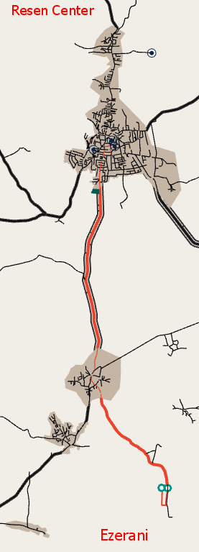
Figure 54: Route 6 to Ezerani village

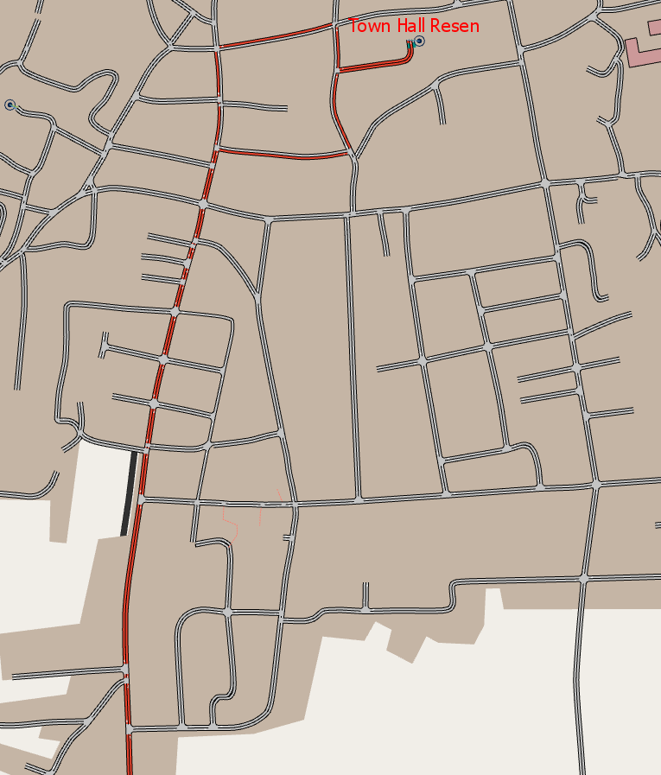
Figure 55: City Hall in Resen Center

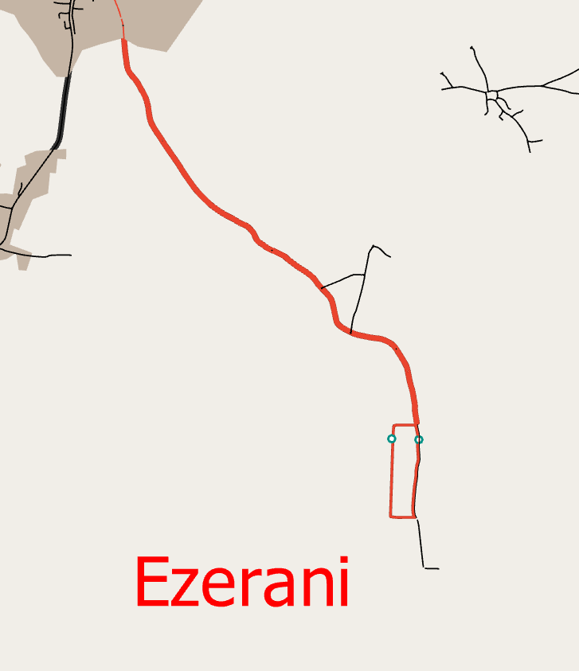
Figure 56: Ezerani village
Figure 57 shows the route to Zlatari village and the intermediate stops. The stops are identified with green circles when they are imported in road sections on Aimsun and are selected for a specific public transport route. Two minutes were chosen as stop duration.
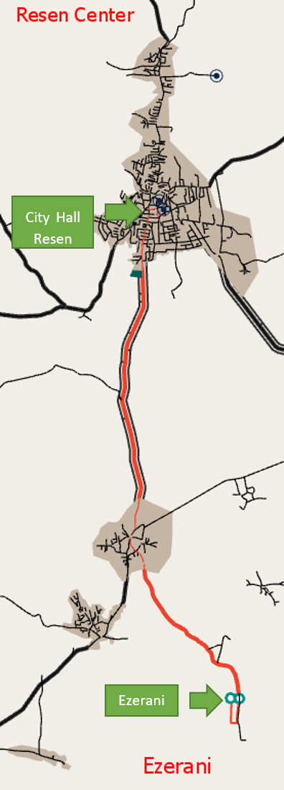
Figure 57: Route 6 to Ezerani village and the intermediate stops

After designing the route and inserting the intermediate stops, a “Dynamic Traffic Scenario (DTS)” considering this public transport route was run. As there were no traffic data for the road sections included in the DTS, and for Bitola Municipality generally, “Google Maps: Traffic” was used. Google Traffic informs about speed limits using a color code. This code, described above, was used to insert traffic flow values in Aimsun. Figure 58 shows a typical dynamic traffic scenario on City Hall Resen.
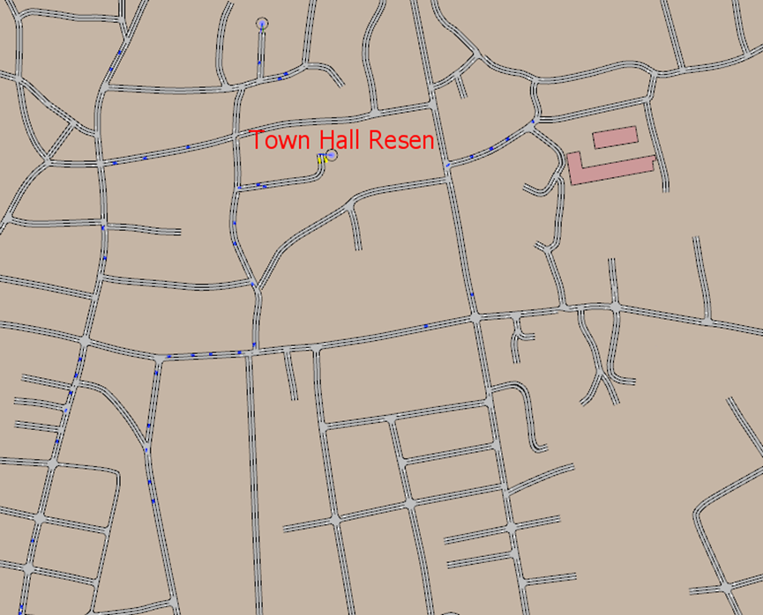
Figure 58: A typical traffic dynamic scenario in City Hall Resen
Given the public transport line (route), its stops (origin, intermediate stops and destination) and a ran simulation in Aimsun, a position-time diagram was exported. This diagram illustrates the position of the bus as a function of time. Figure 59 shows the pattern of position and time for route 6 to Ezerani village, including the intermediate routes:
- Stop 1: City Hall Resen (origin)
- Stop 2: Ezerani
- Stop 3: Ezerani (2)
- Stop 4: City Hall Resen (destination)

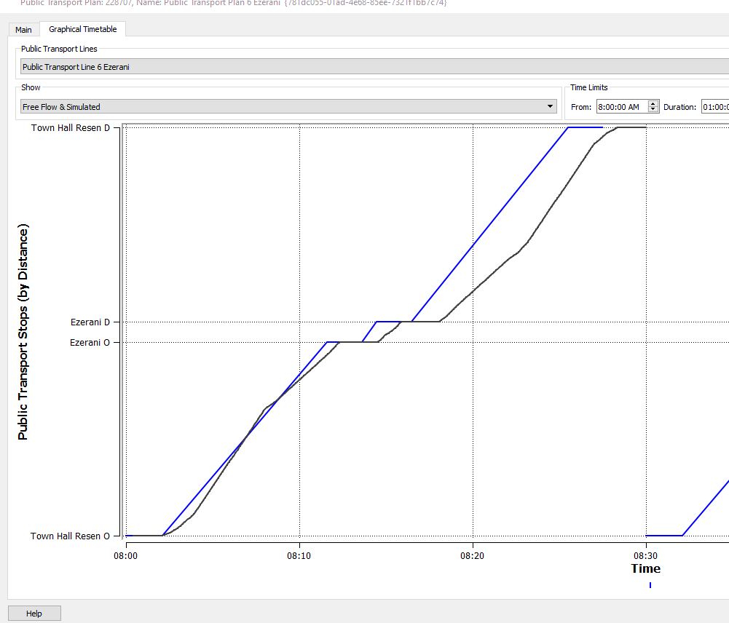
Figure 59: The position-time diagram for route 6 to Ezerani village

In Figure 59 there are two lines, of different coloring. There is a blue line representing free flow conditions, and a black line representing real traffic conditions. For estimating travel conditions, simulations were performed using a dedicated software. The simulations were key for calculating the time for the bus to travel between stops, and to calculate overall trip time from origin to destination. The blue line stands for free flow conditions, namely road signage, road geometry and overall road traffic are not considered. These parameters exist in realistic traffic conditions causing significant latencies. Thus, the black line indicates more time for reaching the destination than the blue line. On the other hand, Aimsun simulation considered bus accelerations and decelerations after and before stops, road geometry, traffic signaling and rules, and traffic in the network, making the simulation realistic.

As we see in Figure 59, there is a blue line (free flow conditions) and a black line (real traffic conditions). Blue lines correspond to free flow and start every 30 minutes to compare free flow with bus position on the route relatively to time during simulation. The simulation was crucial to calculate the time the bus needs to travel from stop to stop, and to calculate overall time (from origin to destination). Free flow was not realistic as it assumes maximum speed for the whole trip. On the other hand, Aimsun simulation considered bus accelerations and decelerations after and before stops, road geometry, traffic signaling and rules and other vehicles in the network. Black lines differ from blue lines, with the black ones representing the simulated (realistic) scenario. This distinction was necessary in order to compare free flow to simulated conditions, not only relative to time, but also relative to speed (slope of time-position figure). The simulation started at 8:00 and there is a deviation from free-flow line. In particular, simulation starts at 8:00 and ends at 08:30 (duration=30 minutes), while in free flow conditions the bus starts at 8:00 and ends at 08:28 (duration=28 minutes).
It is considered that the minibus always follows the same route (to Ezerani) with the same start (Town Hall) and the same end (Town Hall), without stopping for charging or for starting another route. This assumption was considered in simulations to calculate the average duration of route 6, considering stop, road geometry, signaling and traffic conditions.

Route 7 to villages Dolno Dupeni and Brajchino
After importing the map (see Figure 21), including the whole region of Resen’s Center and the villages around it, the best route to Evla and Bolno villages, route 7, was designed. A public transport line was created by selecting the appropriate road sections consecutively, according to data collected by Resen Municipality. Afterwards, the stops were defined, in accordance with citizens’ needs. Five stops were designed, as follows:
- Stop 1: City Hall Resen (origin)
- Stop 2: Dolno Dupeni
- Stop 3: Brajchino
- Stop 4: Brajchino (2)
- Stop 5: City Hall Resen (destination)
Figure 60 shows route 7 (71.65 km), to Dolno Dupeni and Brajchino villages. Figures 61 and 62 show parts of this route, City Hall in Resen, Dolno Dupeni and Brajchino villages.

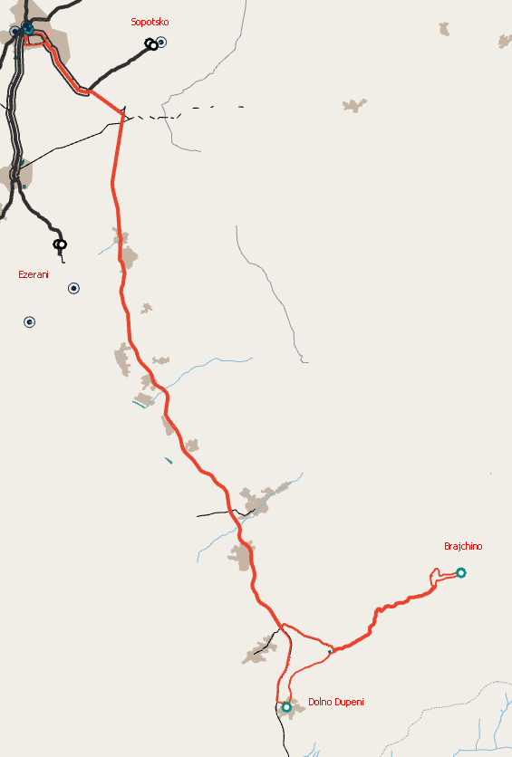
Figure 60: Route 7 to Dolno Dupeni and Brajchino village

Figure 61: City Hall in Resen Center

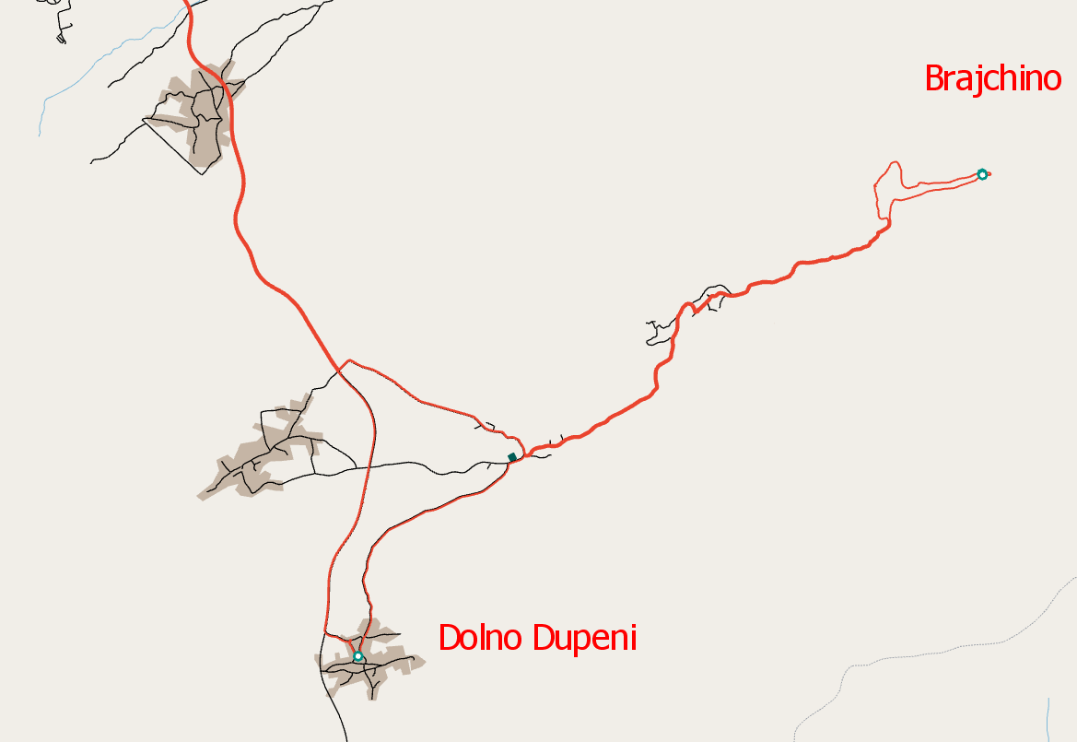
Figure 62: Dolno Dupeni and Brajchino villages
Figure 63 shows the route to Dolno Dupeni and Brajchino villages and the intermediate stops. The stops are identified with green circles when they are imported in road sections on Aimsun and are selected for a specific public transport route. Two minutes were chosen as stop duration.
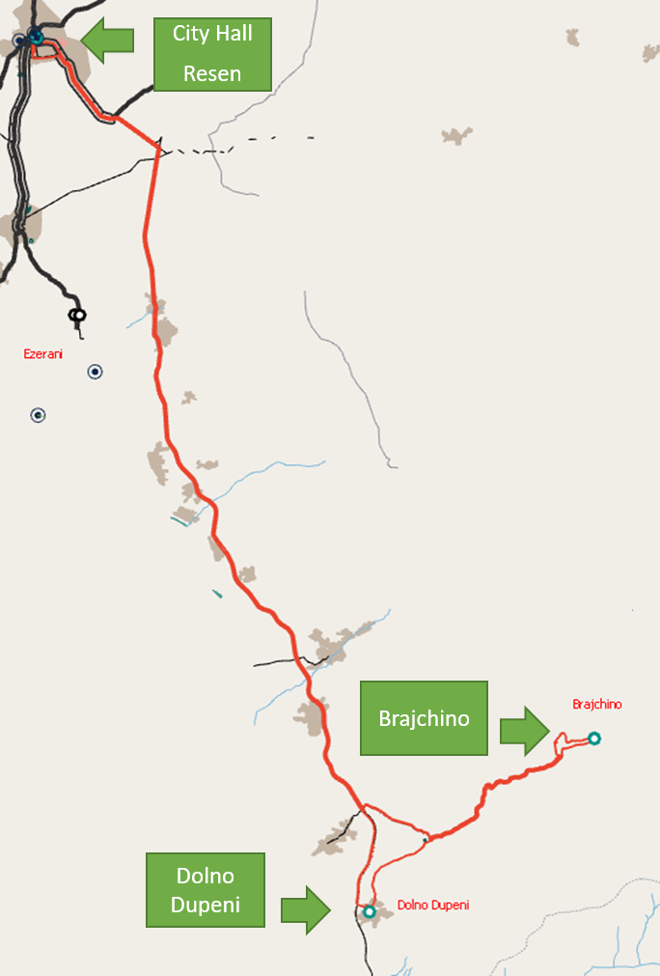
Figure 63: Route 7 to Dolno Dupeni and Brajchino villages and the intermediate stops
After designing the route and inserting the intermediate stops, a “Dynamic Traffic Scenario (DTS)” considering this public transport route was run. As there were no traffic data for the road sections included in the DTS, and for Bitola Municipality generally, “Google Maps: Traffic” was used. Google Traffic informs about speed limits using a color code. This code, described above, was used to insert traffic flow values in Aimsun. Figure 64 shows a typical dynamic traffic scenario on City Hall Resen.
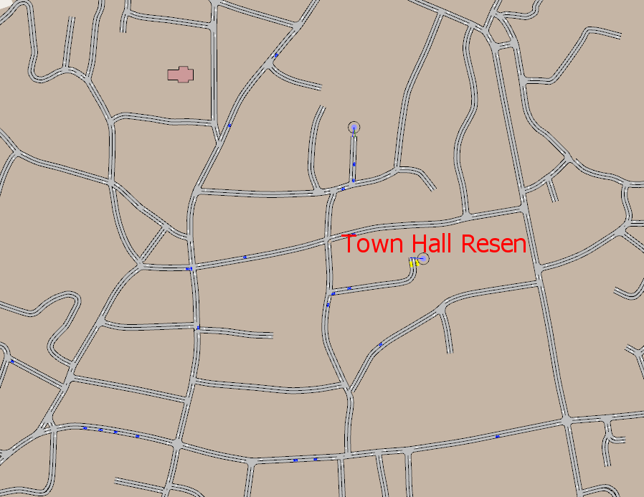
Figure 64: A typical traffic dynamic scenario in City Hall Resen
Given the public transport line (route), its stops (origin, intermediate stops and destination) and a ran simulation in Aimsun, a position-time diagram was exported. This diagram illustrates the position of the bus as a function of time. Figure 65 shows the pattern of position and time for route 7 to Dolno Dupeni and Brajchino villages, including the intermediate routes:
- Stop 1: City Hall Resen (origin)
- Stop 2: Dolno Dupeni
- Stop 3: Brajchino
- Stop 4: Brajchino (2)
- Stop 5: City Hall Resen (destination)

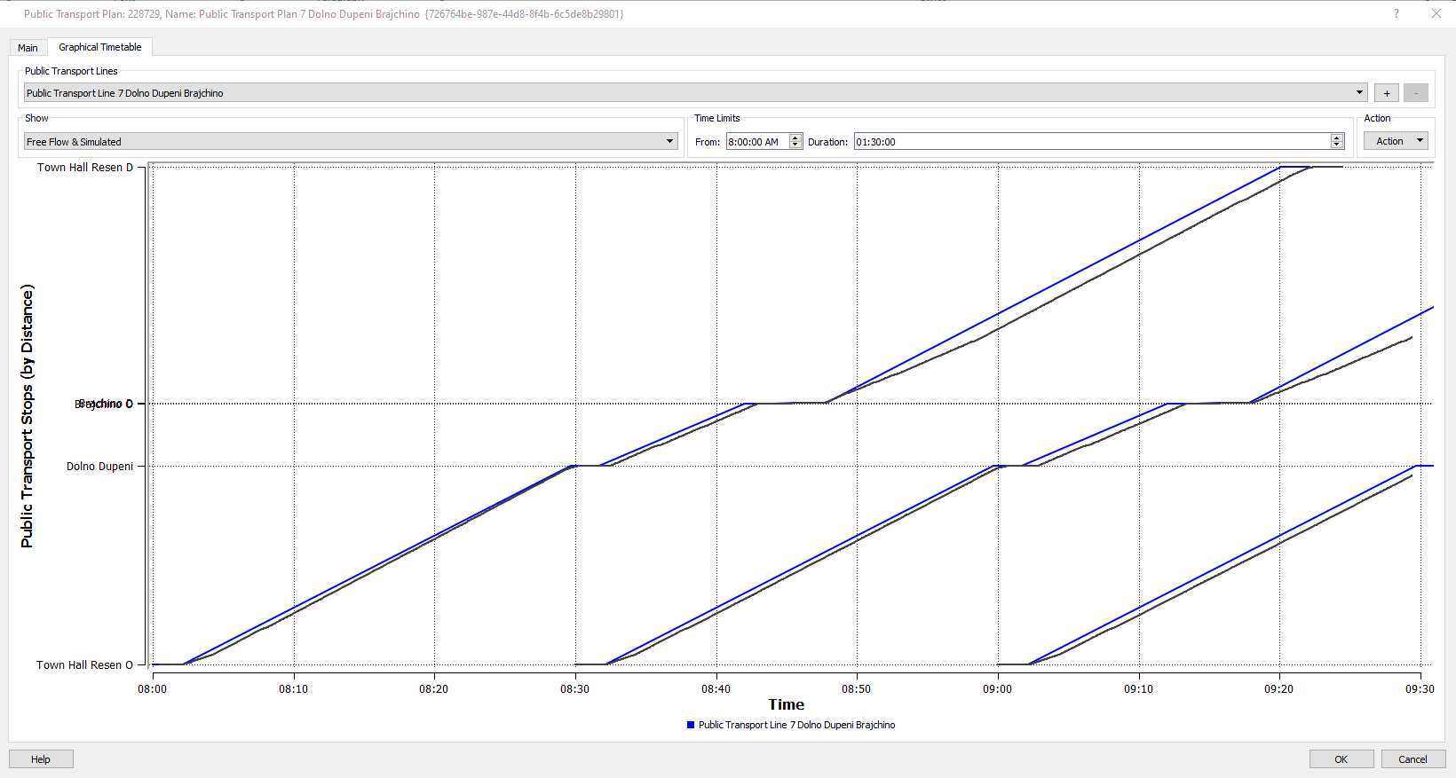
Figure 65: The position-time diagram for route 7 to Dolno Dupeni and Brajchino villages

In Figure 65 there are two lines, of different coloring. There is a blue line representing free flow conditions, and a black line representing real traffic conditions. For estimating travel conditions, simulations were performed using a dedicated software. The simulations were key for calculating the time for the bus to travel between stops, and to calculate overall trip time from origin to destination. The blue line stands for free flow conditions, namely road signage, road geometry and overall road traffic are not considered. These parameters exist in realistic traffic conditions causing significant latencies. Thus, the black line indicates more time for reaching the destination than the blue line. On the other hand, Aimsun simulation considered bus accelerations and decelerations after and before stops, road geometry, traffic signaling and rules, and traffic in the network, making the simulation realistic.
As we see in Figure 65, there is a blue line (free flow conditions) and a black line (real traffic conditions). Blue lines correspond to free flow and start every 30 minutes in order to compare free flow with bus position on the route relatively to time during thesimulation. The simulation was crucial in order to calculate the time the bus needs to travel from stop to stop and to calculate overall time (from origin to destination). Free flow was not realistic as it assumes maximum speed for the whole trip. On the other hand, Aimsun simulation considered bus acceleration and deceleration after and before stops, road geometry, traffic signaling and rules and other vehicles in the network. Black lines differ from blue lines, with the black ones representing the simulated (realistic) scenario. This was necessary in order to compare free flow with simulated conditions, not only relative to time, but also relative to speed (slope of time-position figure). The simulation started at 8:00 and there is a deviation from free-flow line. In particular, the simulation starts at 8:00 and ends at 09:24 (duration= 1 hour and 24 minutes), while in free flow conditions the bus starts at 8:00 and ends at 09:21 (duration= 1 hour and 21 minutes).
It is considered that the minibus always follows the same route (to Dolno Dupeni and Brajchino) with the same start (Town Hall) and the same end (Town Hall), without stopping for charging or for starting another route. This assumption was considered in simulations to calculate the average duration of route 7, considering stop, road geometry, signaling and traffic conditions.

Route 8 to Prespes-Florina-Bitola-Resen
After importing the new map (see Figure 66) including the whole cross-border region (Resen, Bitola, Prespes, Florina), the best route to all four municipalities, route 8, was designed. A public transport line was created by selecting the appropriate road sections consecutively. Five stops were designed, as follows:
- Stop 1: Resen Town Hall
- Stop 2: Prespes Town Hall
- Stop 3: Florina Town Hall
- Stop 4: Bitola (Sports Hall Boro Churlevski)
- Stop 5: Resen Town
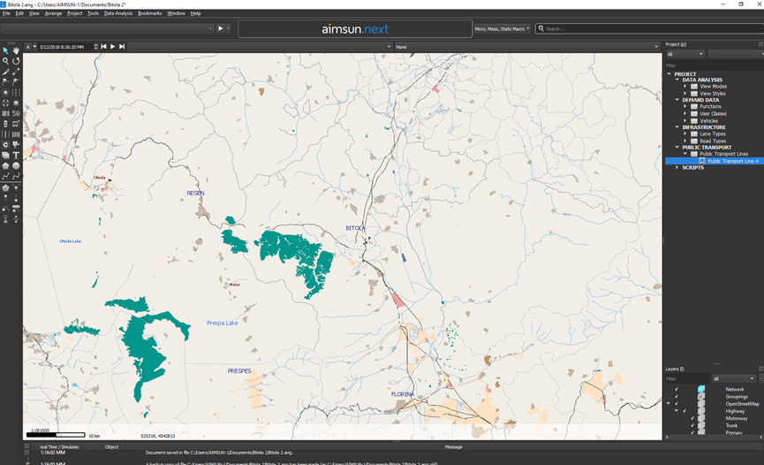
Figure 66: The new map imported in Aimsun Software for the tourist route to all four municipalities

Figure 67 shows route 7 to the four municipalities of the cross-border region.
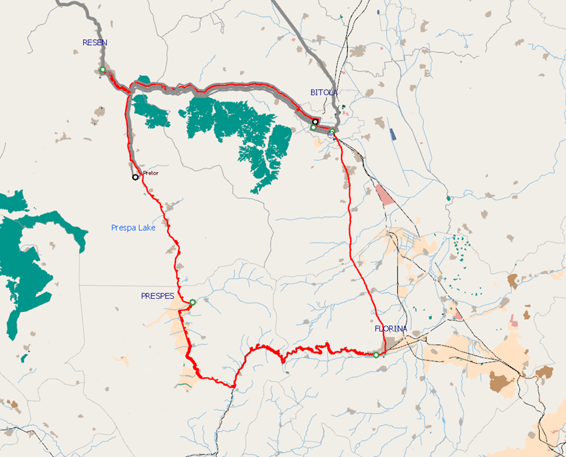
Figure 67: Route 8 to the four municipalities of the cross-border region

Figure 68 shows route to the four municipalities and the intermediate stops. The stops have yellow color when they are designed in Aimsun and green color when they are imported in road sections, becoming, in this way, part of the public transport line. Normal stop is the type that was chosen for the intermediate stops and terminal stop is the type used for the last stop of the route. Two minutes were chosen as stops’ duration.
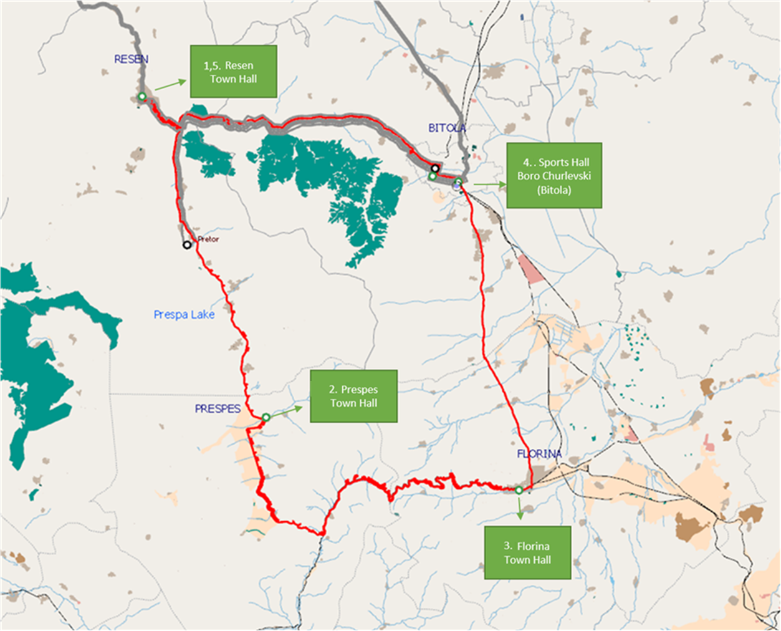
Figure 68: Route 8 to the four municipalities and the intermediate stops

After designing the route and inserting the intermediate stops, a “Dynamic Traffic Scenario (DTS)” considering this public transport route was run. As there were no traffic data for the road sections included in the DTS, and for Bitola Municipality generally, “Google Maps: Traffic” was used. Google Traffic informs about speed limits using a color code. This code, described above, was used to insert traffic flow values in Aimsun. Figures 69, 70 and 71 show a typical dynamic traffic scenario on Florina Municipality Multipurpose Hall, in Prespes Town Hal and in Resen Town Hall, respectively.
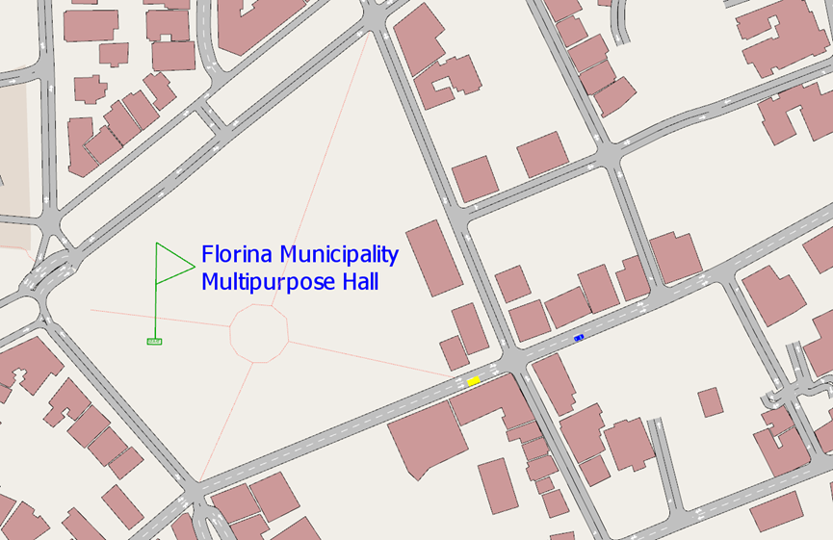
Figure 69: A typical traffic dynamic scenario in Florina Municipality Multipurpose Hall

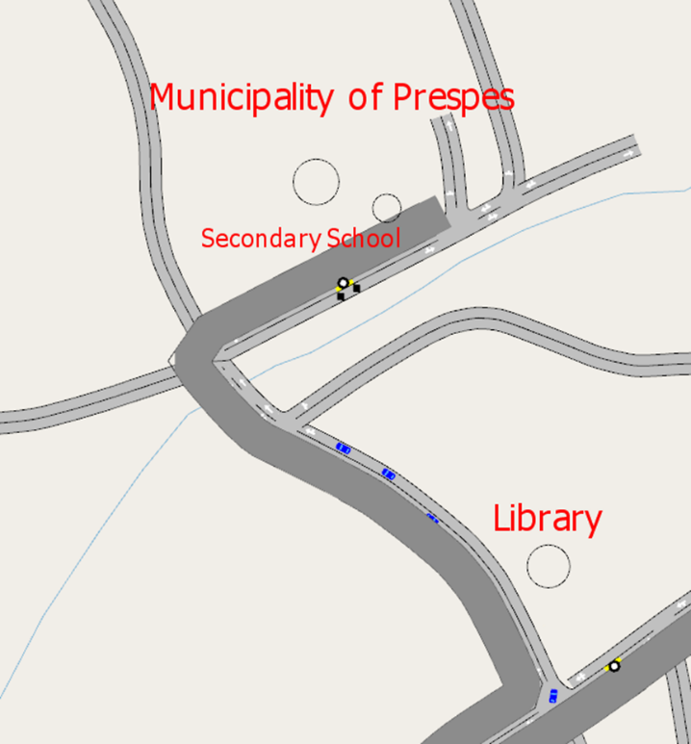
Figure 70: A typical traffic dynamic scenario in Prespes Town Hall (Agios Germanos)
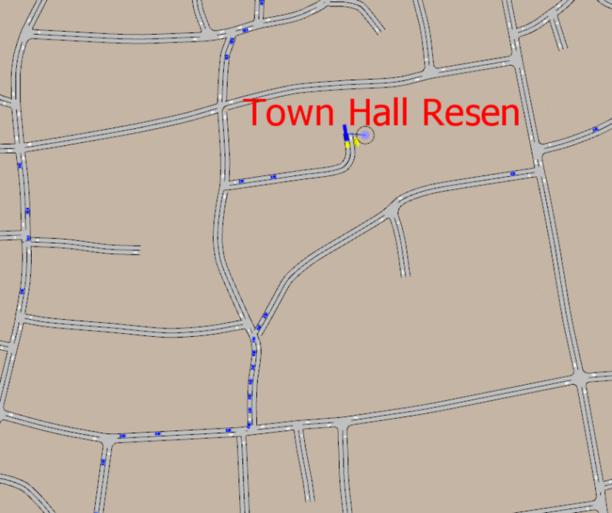
Figure 71: A typical traffic dynamic scenario in Resen Town Hall

Given the public transport line (route), its stops (origin, intermediate stops and destination) and a ran simulation in Aimsun, a position-time diagram was exported. This diagram illustrates the position of the bus as a function of time. Figure 72 shows the pattern of position and time for route 8 to the four municipalities, including the intermediate stops:
- Stop 1: Resen Town Hall
- Stop 2: Prespes Town Hall
- Stop 3: Florina Town Hall
- Stop 4: Bitola (Sports Hall Boro Churlevski)
- Stop 5: Resen Town Hall

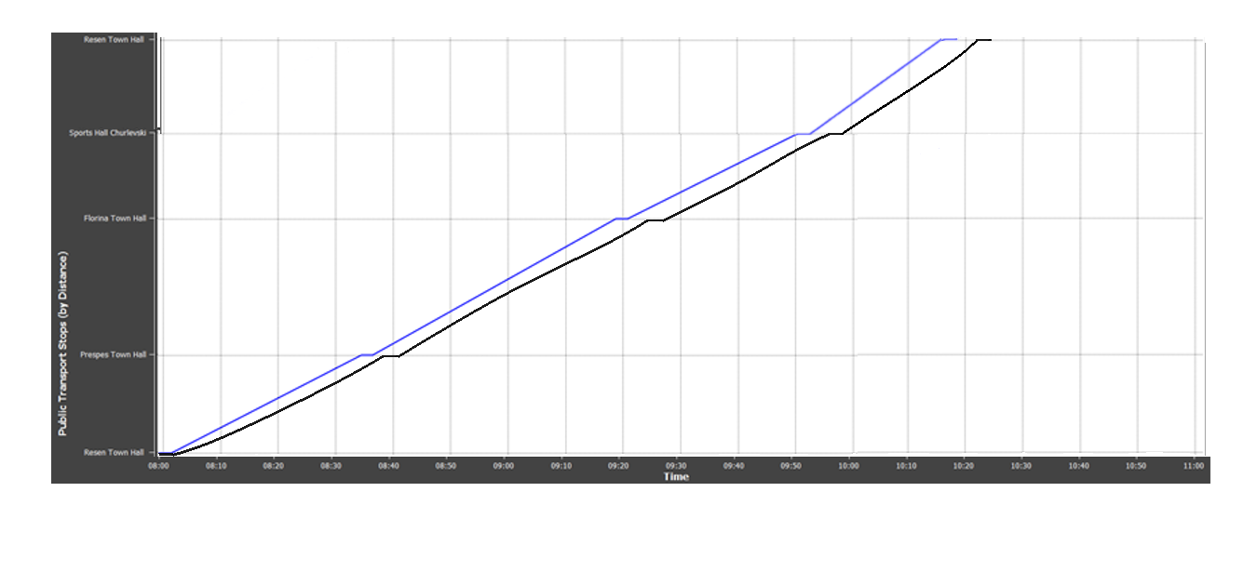
Figure 72: Position-time diagram for route 8 to the four municipalities
In Figure 72 there are two lines, of different coloring. There is a blue line representing free flow conditions, and a black line representing real traffic conditions. For estimating travel conditions, simulations were performed using a dedicated software. The simulations were key for calculating the time for the bus to travel between stops, and to calculate overall trip time from origin to destination. The blue line stands for free flow conditions, namely road signage, road geometry and overall road traffic are not considered. These parameters exist in realistic traffic conditions causing significant latencies. Thus, the black line indicates more time for reaching the destination than the blue line. On the other hand, Aimsun simulation considered bus accelerations and decelerations after and before stops, road geometry, traffic signaling and rules, and traffic in the network, making the simulation realistic.
As we see in Figure 72 there is a blue line (free flow conditions) and a black line (real traffic conditions). The simulation was crucial for calculating the time for the bus to travel between stops, and to calculate overall time (from origin to destination). Free flow was not realistic as it assumes maximum speed for the whole trip. On the other hand, Aimsun simulation considered bus accelerations and decelerations after and before stops, road geometry, traffic signaling and rules, and other vehicles in the network. Black lines differ from blue lines, as the black ones represent the simulated (realistic) scenario. Thus, it is possible to compare free flow with simulated conditions, not only with respect to time, but also speed (slope of time-position figure). The simulation started at 08:00 and there is a deviation from free-flow line. In particular, the simulation starts at 08:00 and ends at 10:28 (duration= 2 hours and 28 minutes), while in free flow conditions the bus starts at 08:00 and ends at 10:22 (duration= 2 hours and 22 minutes). It is assumed that the minibus always follows the same route (to the four municipalities) with the same start (Sports Hall) and the same end (Sports Hall), without stopping for charging or for starting another route. This assumption was considered in simulations in order to calculate the average duration of route 8, considering stop, road geometry, signaling and traffic conditions.
It is considered that the minibus always follows the same route (to all four Municipalities) with the same start (Town Hall) and the same end (Town Hall), without stopping for charging or for starting another route. This assumption was considered in simulations to calculate the average duration of route 8, considering stop, road geometry, signaling and traffic conditions.

Table 3 summarizes the time the bus needs to travel from origin to destination as well as the length of each route in km.

Table 3: Length and duration of each route
Route | 1 | 2 | 3 | 4 | 5 | 6 | 7 | 8
Length (km) | 46.35 | 21.57 | 18.95 | 13.42 | 12.45 | 18.37 | 71.65 | 165
Time (from origin to destination) | 1h 3 min | 43 min | 31 min | 24 min | 24 min | 30 min | 1h 24 min | 2h 28 min

E-minibus scheduling
In this section, e-minibus scheduling, one of the best alternatives for scheduling is presented. Town Hall Resen is the origin and destination of all eight routes thus any sequence of routes is possible. One serious constraint is that e-minibus mixed cycle autonomy will be 200km, while city cycle autonomy can exceed 300km. Moreover, the average time needed for charging fluctuates around 4 hours, making it impossible and inefficient to charge the e-minibus during the day. The itineraries were spread during the day according to users’ needs relative to time. Table 4 shows the suggested scheduling, where route 1 is in yellow, route 2 in blue, route 3 in green, route 4 in orange, route 5 in red, route 6 in pink and route 7 in purple. This schedule can be implemented on any weekday.
Table 4: The suggested e-minibus scheduling

Time | Stop
08:00:00 AM | Town Hall Resen | 1
08:32:00 AM | Stenje School | 1
08:35:00 AM | Stenje School (2) | 1
09:03:00 AM | Town Hall Resen | 1
09:10:00 AM | Town Hall Resen | 2
09:23:00 AM | Evla | 2
09:27:00 AM | Evla 2 | 2
09:38:00 AM | Bolno | 2
09:41:00 AM | Bolno (2) | 2
09:53:00 AM | Town Hall Resen | 2
10:00:00 AM | Town Hall Resen | 3
10:16:00 AM | Gorno Krushje | 3
10:19:00 AM | Gorno Krushje (2) | 3
10:31:00 AM | Town Hall Resen | 3
10:40:00 AM | Town Hall Resen | 4
10:53:00 AM | Sopotsko | 4
10:56:00 AM | Sopotsko (2) | 4
12:04:00 PM | Town Hall Resen | 4
12:10:00 PM | Town Hall Resen | 5
12:22:00 PM | Zlatari | 5
12:25:00 PM | Zlatari (2) | 5
12:34:00 PM | Town Hall Resen | 5
12:45:00 PM | Town Hall Resen | 6
01:00:00 PM | Ezerani | 6
01:03:00 PM | Ezerani (2) | 6
01:15:00 PM | Town Hall Resen | 6
01:30:00 PM | Town Hall Resen | 7
02:02:00 PM | Dolno Dupeni | 7
02:18:00 PM | Brajchino | 7
02:21:00 PM | Brajchino (2) | 7
02:54:00 PM | Town Hall Resen | 7

Figure 73 shows e-minibus’ energy reserve, in kilometers remaining during a day. Table 5 shows the suggested scheduling for the tourist route to all four municipalities (route 8), which can be implemented every weekend morning.

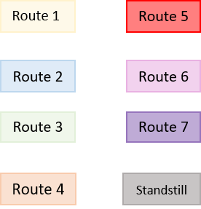
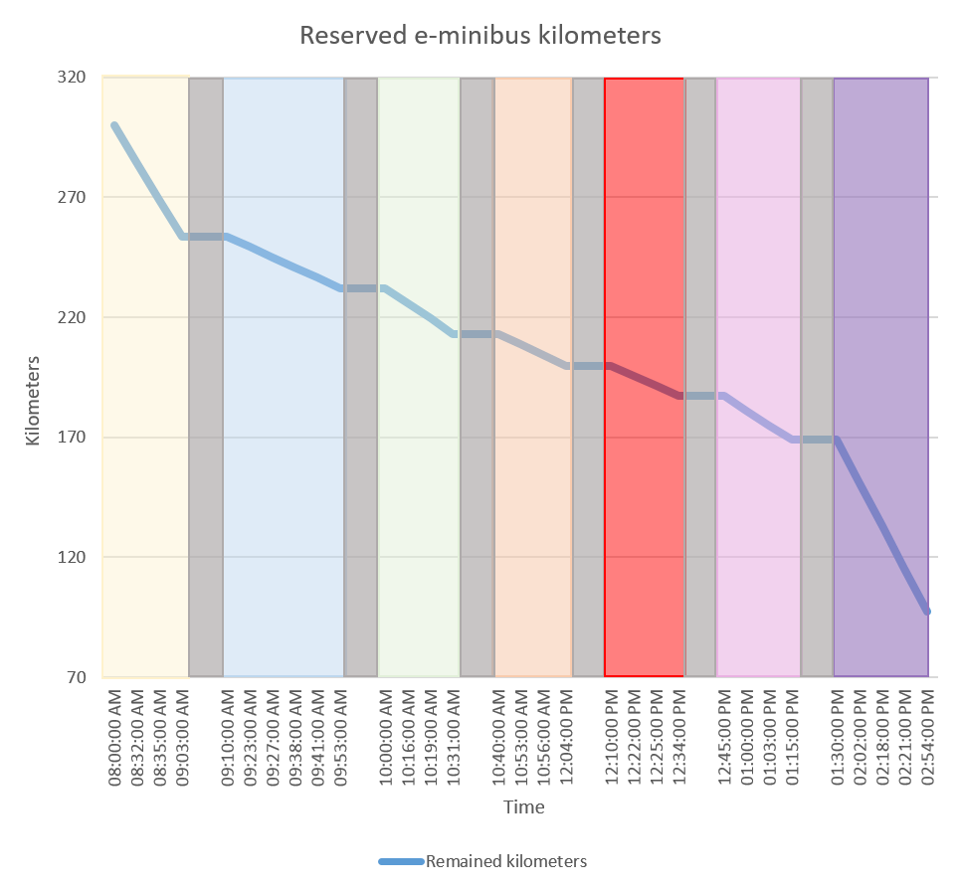
Figure 73: E-minibus energy reserve, in kilometers remaining during a day

Table 5: The suggested e-minibus scheduling for the tourist route
 | Saturday and Sunday
Time | Stop
08:00:00 PM | Resen Town Hall | 8
08:39:00 PM | Prespes Town Hall | 8
09:24:00 PM | Florina Town Hall | 8
09:57:00 PM | Sports Hall Boro Churlevski | 8
10:21:00 PM | Resen Town Hall | 8

Table 6: The e-minibus energy reserve (to the four municipalities), in kilometers remaining during a day

Tourist route the four municipalities
Weekend
Itinerary | km
Resen Town Hall
Prespes Town Hall
Florina Town Hall
Sports Hall Boro Churlevski
Resen Town Hall
Sum | 160
 | <300

Summary
Given Resen suggestions and preferences, in this report the routes were designed and schedules created for the e-minibus of Resen. Using Aimsun, the routes were designed in detail with respect to users’ needs, road and minibus geometry and traffic rules. Creating a realistic traffic simulation, the time needed from stop to stop and the overall time (from origin to destination) were calculated. Considering these times, as well as e-minibus kilometers autonomy, the scheduling was designed to satisfy users’ needs in space and time.

