ANNEX II: TERMS OF REFERENCE
1. BACKGROUND INFORMATION 2
1.1. Partner country 2
1.2. Contracting Authority 2
1.3. Country background 2
1.4. Current situation in the sector 2
1.5. Related programmes and other donor activities 2
2. OBJECTIVE, PURPOSE & EXPECTED RESULTS 2
2.1. Overall objective 2
2.2. Purpose 3
2.3. Results to be achieved by the Contractor 3
3. ASSUMPTIONS & RISKS 3
3.1. Assumptions underlying the project 3
3.2. Risks 3
4. SCOPE OF THE WORK 3
4.1. General 3
4.2. Specific work 3
4.3. Project management 4
5. LOGISTICS AND TIMING 4
5.1. Location 4
5.2. Start date & Period of implementation of tasks 4
6. REQUIREMENTS 5
6.1. Staff 5
6.2. Office accommodation 6
6.3. Facilities to be provided by the Contractor 6
6.4. Equipment 7
7. REPORTS 7
7.1. Reporting requirements 7
7.2. Submission and approval of reports 7
8. MONITORING AND EVALUATION 8
8.1. Definition of indicators 8
8.2. Special requirements 8

BACKGROUND INFORMATION

Partner country
Republic of North Macedonia

Contracting authority
Municipality of Resen
Square Car Samoil no.20
7310 Resen

Country background
The cross-border cooperation programme Greece – North Macedonia supports regional cooperation between Greece and North Macedonia. The Programme's overall objective is to enhance territorial cohesion by improving living standards and employment opportunities holding respect to the environment and by using the natural resources for the upgrading of the tourism products.
The project „Integration of Green Transport in Cities - Green Inter-e-Mobility “ is supported by the cross-border programme “Interreg IPA Cross-border Cooperation Programme Greece- Republic of North Macedonia 2014-2020".
EE is a key priority within the EU Strategy, and this translates into common EU policies for the Member States, including those addressing energy-efficiency. To accelerate the achievement of strategic targets, an integrated approach is needed with coordination between EU/national/regional/local energy policies.
Replacing the current transport modes with more energy-efficient ones, within a regional intelligent transportation system, will support the efficient realization of both the tourist promotion of the area, the sportsmen and student’s daily transportation. The new system will also promote the environmental conservation of the area and the protection of its natural beauty. Moreover, due to the heavy winter periods, residents in this region, and especially elderly, disabled, distant-residents, face great difficulties in their daily transport. This project faces this challenge and facilitates residents in these Municipalities (MUNIs) with the on-demand use of utility electric vehicles (e-vehicles). Furthermore, the solar availability in the region, which is indicated for high performance of energy supply through photovoltaic (PV) panels, could be exploited for replacing the conventional energy used by current transport, with renewable energy. The project is compatible with the broad EU energy policy context such as Climate-Energy packages, Energy Union and decarbonisation of transport, since it creates synergies between Renewable Energy Sources and transport users.

Current situation in the sector
The overall project’s objective is to design and apply an energy-efficient, regional intelligent transportation system with innovative solar-energy charging-stations for e-vehicles in all four Municipalities.
The main project outputs include the promotion of the environmental conservation of the area (through an integrated solution for reducing the carbon footprint of road facilities and transport) and the protection of its natural beauty, the enhancement of the tourist stream towards the cross-border area and of the cross-border cultural and sports relations, through the establishment of the transnational Bitola-Florina tourist route, and the facilitation of sportsmen and students in their daily transport and residents (elderly, disabled, distant-residents) in their daily on-demand transport in all four Municipalities, while the optimal route scheduling and realization of their transport by e-vehicles will greatly decrease their transportation expenses through a 20-year horizon.
Through the Cross-Border approach, including the partner’s cooperation during the development and operation phases, the Municipalities will benefit by the mutual exchange of know-how and experiences among the cross-border actors and end-users of the e-vehicles. Moreover, the public, through the partners’ joint awareness initiatives for green mobility, and by making use of this new innovative technology, will come closer to environmental actions and ideas. Also, the establishment of the cross-border electric minibus route between Florina and Bitola will be combined with other sport and tourist activities and strengthen the relations between the two countries’ population.
The project’s added value is the environmental conservation of the cross-border area, the region’s touristic promotion through transnational actions, the enhancement of the cross-border relations and the facilitation of the area’s residents in their daily transport, through the use of innovative technologies towards green transportation.
With this project Municipality of Resen will influence in development of the infrastructure for using solar energy for charging e- vehicles, also with promotional activities and the pilot installations there will be development of the market for e vehicles and solar charging stations
Policy uptake and community engagement. The direct involvement of partners in the project who have a multiplier role will ensure wide dissemination-awareness raising of the relevant target groups.

Related programmes and other donor activities
There is a strong background in the cooperation between all the partners, since they have all signed Memorandum of Understanding during previous projects. Therefore, the Green Inter-e-mobility project is the implementation of their commitment to cooperate and apply synergetic actions.. Also there is existing experience of successful cooperation between all the partners in the energy efficiency and transportation fields. The region offer a great number of touristic attractions and therefore, an intelligent network of electric mini-buses will bring added-value to these attractions. Additionally, the cross-border interconnection of these touristic sites will be enhanced by a regular cross-border route of a “touristic electric mini-bus”. Such an electric mini-bus interconnection can facilitate tourists sportsmen and the local population to identify many common characteristics between the two regions.
The Green Inter-e-mobility project directly addresses the topics of the Work programme “10. Secure, Clean and Efficient Energy”. More specifically, the project is compatible with the broad EU and national energy policy context such as Climate-Energy packages and it contributes to the following expected impacts:
• The EU power network will be capable of integrating large share of renewable exceeding 50% by 2030, in particular variable energy sources.
• Creation of synergies with transport users (e.g. services to the grid with smart charging) / support the decarbonisation of transport.
Additionally, the project contributes to the regional and local strategy on efficient transport of students, public servants and disabled people.
A number of donors have supported environmental and energy sector in relation to improvement of the Energy Efficiency and reduction of GHG emissions by the donors, including the EU, World Bank Group, the Swiss Agency for Development and Cooperation and the UNDP.

OBJECTIVE, PURPOSE & EXPECTED RESULTS

Overall objective
The overall objective of the project of which this contract will be a part is as follows:
The main project's objective is to design and apply an energy-efficient, regional intelligent transportation system-ITS which will support the efficient realization of both the tourist promotion of the cross-border area, the student’s daily transport and the facilitation of residents in their daily transport. Specific objectives are:
(a)The added value of the area's touristic sites through the e-minibuses routes.
(b)The enhancement of the cross-border cultural relations through the route connecting Bitola-Florina.
(c)An optimal route scheduling in coordination with the design & implementation of PV charging stations for minibuses.-Programme’s object. : Improving cross-border road access & mobility with targeted interventions of small scale infrastructure
(d)The realization of the ITS that will facilitate both tourists, residents’ (elderly, disabled, distant-residents) and students’ daily transportation. Especially for accessibility of disabled people, a utility e-vehicle and a relative smart phone application is predicted.-Progr.obj. : ICT systems & equipment to improve check point services & facilities
(e)The decarbonisation of transport and the support to the electricity grid.-Progr.obj.: Integrated solutions for reducing the carbon footprint of road facilities & transport in cross-border area
(f)Cooperation between partners during the optimal route studies, development & operation phases.
(g)Public awareness about the integration of e-vehicles fuelled by the sun in cities, and communication & dissemination of the project results to national, regional & local authorities to promote green transport.-Progr.obj.: Small scale investments in energy efficiency, in check point facilities & public buildings of cross-border area, including joint awareness initiatives for energy efficiency

Purpose
The purposes of this contract are as follows:
Procurement of the communication system that will include technical solution, equipment, installation, application, software for communication between two electric vehicles, charging station, users etc. And everything needed for this service to be completed and functional.

Results to be achieved by the contractor
The expected results by the contractor are
Establishing functional communication system that will include technical solution, equipment, installation, application, software for communication between two electric vehicles, charging station, users etc. and everything needed for this service to be completed and functional.

ASSUMPTIONS & RISKS

Assumptions underlying the project
• Good cooperation between all parties involved in the project
• Constant and timely support from the Project team;

Risks
• Low level of communication among the project stakeholders
• Failure to comply with the respective deadlines for completion and launching of the tender procedures;

SCOPE OF THE WORK

General

Description of the assignment
Establishing functional communication system that will include technical solution, equipment, installation, application, software for communication between two electric vehicles, charging station, users etc. and everything needed for this service to be completed and functional.

Geographical area to be covered
Republic of North Macedonia, Municipality of Resen

Target groups
Local citizens, sportsmen, students, tourist’s elderly, disabled and distant-residents etc.

Specific work
Procurement of the communication system that will include technical solution, equipment, installation, application, software for communication between two electric vehicles, charging station, users etc. and everything needed for this service to be completed and functional. Minimum warranty period of the whole system is 12 months and including this period the contractor must maintenance whole system including everything needed for that. All equipment, ownership and rights for the whole system hardware, software etc. belongs to the municipality.
Municipality of Resen will be supplied with two electric cars, one electric combe 8+1 seats and one electric vehicle 5 seats utility vehicle. These vehicles will need to be monitored via the Internet for their exact location, current consumption, and available battery power. Based on the above data, the available kilometers, the available itineraries and the optimal routes of the electric cars will be calculated.
Technical description of communication system

General
Municipality of Resen will supply “electric combe with 8+1 seats” and a "utility vehicle with 5 seats ". These vehicles will need to be monitored via the Internet for their exact location, current consumption, and available battery power. Based on the above data, the available kilometers, the available itineraries and the optimal routes of the electric cars will be calculated.
To monitor the condition of the car, an android application will be developed which will be connected to the car software via wireless connection either via Bluetooth, or via Wifi, or via 4G network. If all four networks are available, it will be recommended connecting via Bluetooth due to reduced power consumption.
All the information of the car status will be transferred through the android application to a "Smart Transport Information System" which will monitor the car's electricity consumption and based on the remaining energy will inform the driver of the car with the available kilometers, the suggested routes, and the suggested stops for charging the car.
Through the Information System, the citizens will be able to control the availability of electric cars and to reserve the electric vehicle for the allowed transports for the citizens, such as e.g. their tour in tourist destinations, transfer to municipal schools and similar.

Monitoring of energy consumption
The android device that which will be installed inside the electric vehicle will receive at regular intervals information on the consumed instantaneous energy through the wireless connection of the device to the car computer. This information will be automatically transmitted via 4G wireless connection to the smart information system.
The instantaneous energy consumption will yield the average energy consumed, which is required to calculate the available kilometers. In calculating the available remaining kilometers until the next measurement, the driver profile in energy consumption from previous years and the current route will be taken into account, since the electricity consumption of an electric car depends to a large extent on the route which travels (altitude difference between current position and final destination, driving speed, etc.)

Monitoring of electronic vehicles
For the tracking of the vehicle, the GPS will be used. In case the Electric Vehicle (EV) is equipped with a GPS already, it will be used In a different case, the tablet GPS signal will be used.

Technical evaluation .
At the end of the work of the implementation of the Information System, the web server system will be installed in a space that will be indicated by a competent service of the Municipality. This will be followed by a period of testing of the individual subsystems as well as the integrated system. Finally, there will be a field test inside the electric vehicles for the correct and smooth operation of the whole system.
At the end of the trial period, a complete technical evaluation of the entire system should be performed. This should include statistics on the use of electric cars, how many kilometres they travelled, how much electricity was consumed, how many kilos of carbon dioxide were not released into the atmosphere due to electricity, how many routes were carried out, how these routes were distributed, how many citizens were served and how many used electric cars.
In order to evaluate the service of the citizens in the information system, a website should be created that will record the experiences of the citizens and the degree of their service on a Linkert scale.

Android application development
As part of the research project, an android application will be developed which will read the status of the battery of the electric car, the speed of the vehicle, the name of the driver, the geographical location of the car, the instantaneous consumption and will transfer all these information in the Intelligent Transport Information System to calculate the optimal routes.
This application will be available for free download through the Google Play Store, in case it is necessary to reinstall the application entitled "Green Inter-e-Mobility".
The android application will enable users to see the available electric cars, to communicate with the backend of the Information System in order to display the data that they will receive from the electric car, as well as to make a reservation of the electric car for future use.

The Android device
For the needs of the project, an android device with pre-installed application of the program with the following features or higher capabilities must be delivered.
Reference Model: Galaxy Tab Active3 or another model of equivalent or higher capabilities, having at least the following characteristics:
Number of Cores: ≥8 (Octa-Core) or higher
Screen: at least 8 “
Memory (RAM): At least 4 GB
Storage: ≥64 GB (built-in) or higher
Graphics: ARM Mali-G72 MP18 (IGP) or higher capabilities
Illustration: 1920 × 1200, 283dpi, multi-touch, digitization, PLS (or equivalent)
Connections: 1x USB-C 3.0 socket (or equivalent)
Wireless Networks: WLAN 802.11a / b / g / n / ac / ax, Bluetooth 5.0, NFC, ANT + (or equivalent)
Card reader: microSDXC (up to 1 TB) (or equivalent)
Webcam: At least 5 megapixels (front)
Operating system: Android 10 or later
Battery: Li-ion, At least 5050mAh
Dimensions: At least 213.8 × 126.8 × 9.9 mm
Features: Proximity sensor, acceleration sensor, GPS position sensor, light sensor, space sensor, barometer, input pen (S-Pen), MIL-STD-810H certified, IP68 certified, replacement battery, fingerprint reader.
(or equivalent)
Manufacturer warranty: At least 3 years.

Installation of the android device in the car
The android application will be installed on an android device that will be installed inside the car. In order for the driver of the electric car to have easy access to the application, the android device must be placed on a special base either on the windshield or on the dashboard of the car, see pictures below
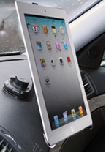
Tablet installation in the car dashboard

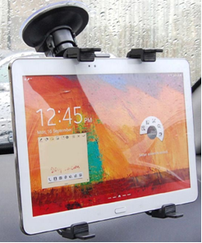
Tablet installation on the car windshield

The cradle should be able to support tablet from 8 "inches to 10.1" inches with Adjustable Arm.
Its support base must be CE certified, and it is recommended to be certified or recommended by the car manufacturer.
The base should be 360 ​​degree rotatable and fitted with a suction cup for easy mounting on the windshield or dashboard of the car.
The base must be lined with non-slip soft material to prevent scratches or bumps on the device.

Το The transport information system.
For the purposes of efficient management of electric vehicles and charging stations, an Intelligent Transport Information System should be developed. The construction of the Information System will be based on Artificial Intelligence and the Internet of Things.
This Information System must take into account:
a) The maximum mileage that the electric vehicle can travel,
b) The maximum capacity of the vehicle batteries,
c) The current charge level of the vehicle batteries,
d) The current geographical location of the vehicles
e) Scheduled itineraries for the rest of the day
f) The total kilometres that the vehicle can travel before the next charge
g) The energy requirement for the execution of the other itineraries, based on the kilometers, the altitude difference of the ground and the traffic within the cities
(h) The categorization as to the necessity of all other itineraries
i) The spatial distribution, the availability of time and the power of the existing charging stations in the area.
j) Charging costs per charging station, per day.
The information system will be based on artificial intelligence. Its decision algorithms will accept as input all the above information as input data and will provide the driver of the electric vehicle with information on:
(i) The optimal route of each route.
(ii) The other routes to be performed and their total kilometer.
(iii) The remaining driving time based on the remaining battery capacity.
(iv) The percentage of available battery capacity
(v) The nearest charging stations, their availability and charging capacity.
vi) Suggested charging time and the cost of this charging.
All information transmission between the electric car and the information system will be via the 4G LTE wireless network. An Android application must be built to connect the battery of the electric car and the information system. This application will read the battery status of the vehicle and its geographical location. This information will be transmitted over the 4G network at regular intervals to the Information System. The Information System will process all input data a) to j) and provide the information i) to vi) to the EV driver.
The implementation of the Artificial Intelligence Information System will be developed based on the Tensorflow and Keras software applications. (or equivalent) TensorFlow and Keras are software supported by google, popular for creating neural networks and machine learning applications. They will have inputs information from a) to j), and train and maintain a flowchart. The main advantage of TensorFlow is that it can run on different platforms as well as GPUs. TensorFlow was developed in C ++ and can be used by other software, such as Python.
For the implementation of the above system, the Procurement of a communication and monitoring system of electric vehicles of the municipality (two electric vehicles) should be done. The system will consist of three main subsystems: (i) the backend together with the Database, hosted on a web server, (ii) the administrator frontend, which is a web application, and (iii) the user frontend, which is a mobile application.
The backend of the system will communicate with the central data system of the manufacturer and will receive the data of the electric vehicles with appropriate authentication, through secure protocols, through the cloud of the manufacturer. This data will be stored in the project database.
The functions of the system will be managed by an administrator (application and database administrator) through the frontend web application. Through the web environment, the administrator will be able to add / remove cars and charging stations from the system, shut down cars in case of failure and have the general supervision of the system.
The web server software, ie the web application will communicate with the central data system using secure OAuth authentication and will provide data / information for each electric vehicle. The mobile application that will be created will enable the user to see the above information for each vehicle and to be able to rent it for a certain period. The user will also be able to see information such as where the available charging stations are, their availability and cost. By using GPS from the mobile application, the system will be able to use smart algorithms to suggest to the user smart stops for charging or to prevent the user from long distances that will create a problem of energy savings.

The architecture of the higher information system

The architecture of the information system and the dissemination of information is shown in picture below
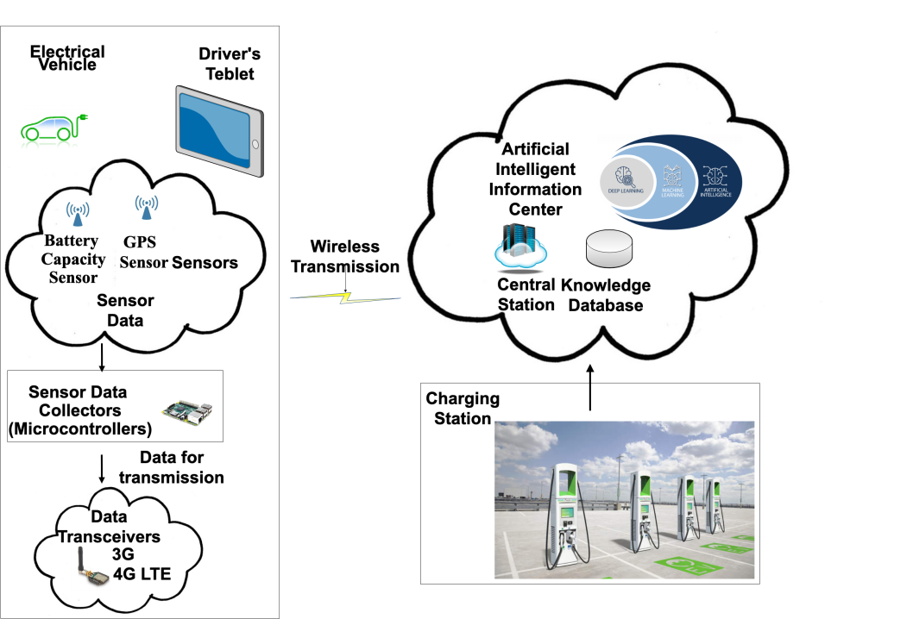
Picture The architecture of the Information Transmission System

As it can be seen from the picture, the information collected from the car and Tablet sensors, is transmitted over the 4G wireless network to the information system. The information system also collects information via the internet about the available charging stations and transfers the processed information back to the driver with the help of the Tablet.
At the end of the work of the implementation of the Information System, the web server system will be installed in a space that will be indicated by a competent service of the Municipality. This will be followed by a period of testing of the individual subsystems as well as the integrated system. Finally, there will be a field test inside the electric vehicles for the correct and smooth operation of the whole system.
At the end of the trial period, a complete technical evaluation of the entire system should be performed. This should include statistics on the use of electric cars, how many kilometres they travelled, how much electricity was consumed, how many kilos of carbon dioxide were not released into the atmosphere due to electricity, how many routes were carried out, how these routes were distributed, how many citizens were served and how many used electric cars.
In order to evaluate the service of the citizens in the information system, a website should be created that will record the experiences of the citizens and the degree of their service on a Linkert scale.
Minimum warranty period of the whole system is 12 months and including this period the contractor must maintenance whole system including everything needed for that. All equipment, ownership and rights for the whole system hardware, software etc. belongs to the municipality.

Project management

Responsible body
The Contracting Authority for the contract is Municipality of Resen

Management structure
The Contracting Authority is Municipality of Resen, the Republic of North Macedonia and in that capacity, it is responsible for launching the service tender procedure, sign the service contract, authorize payments to the contractor and handle the financial management and control during project implementation.
The Contracting Authority is unit of local self-government. Its competences are implemented in line with Local self-government law as well as other legislation. The Contracting Authority is consisting of decision makers and administration. There are two bodies of decision maker: Mayor and Council of Resen Municipality. Two bodies are elected, by the population, on local municipal elections, which are organized every four years. The Council of municipality is consisting of 15 members. One member is appointed as President of the municipal Council. The project ″Integration of Green Transport in Cities (Green Inter e- mobility) ″ is a partner project implemented by 6 (six) partners in Republic of Greece and Republic of North Macedonia, financed by INTERREG IPA Cross Border Programe Greece - R of North Macedonia 2014-2020. The Mayor of Resen municipality with Decision appointed project team which is obligated to implement all project activities. The Project team has 8(eight) members (one project manager and one financial manager). During the project implementation, all needed decisions shall be signed by the Mayor as authorized person for project implementation.

Facilities to be provided by the contracting authority and/or other parties
The contracting authority has no obligations to provide any facilities

LOGISTICS AND TIMING

Location
Municipality of Resen , Republic of North Macedonia

Start date & period of implementation of tasks
From the date when the contract will be signed until the end of the project Green Inter e Mobility which is now 30.12.2021 (If the implementation period for the project will be extended the implementation period of this contract will be extended too. Please see Articles 19.1 and 19.2 of the special conditions for the actual start date and period of implementation.

REQUIREMENTS

Staff
Note that civil servants and other staff of the public administration of the partner country, or of international/regional organisations based in the country, shall only be approved to work as experts if well justified. The justification should be submitted with the tender and shall include information on the added value the expert will bring as well as proof that the expert is seconded or on personal leave.

Key experts
Key expert:
Qualifications and skills
University degree (bachelor, master or PhD) related to engineering or programming or ICT, and in the absence of a degree as required in the previous paragraph, the expert should prove that he has competence in the field related to this activity based on previous similar tasks for at least 3 years.

General professional experience
Minimum of three years of professional experience in fields related to these activities.
Specific professional experience
Experience with communication or monitoring systems
All experts must be independent and free from conflicts of interest in the responsibilities they take on.

Other experts, support staff & backstopping
CVs for experts other than the key experts should not be submitted in the tender but the tenderer will have to demonstrate in their offer that they have access to experts with the required profiles. The contractor shall select and hire other experts as required according to the needs. The selection procedures used by the contractor to select these other experts shall be transparent, and shall be based on pre-defined criteria, including professional qualifications, language skills and work experience.
The costs for backstopping and support staff, as needed, are considered to be included in the tenderer's financial offer.

Office accommodation
Office accommodation for each expert working on the contract is to be provided by the contractor.

Facilities to be provided by the contractor
The contractor shall ensure that experts are adequately supported and equipped. In particular it must ensure that there is sufficient administrative, secretarial and interpreting provision to enable experts to concentrate on their primary responsibilities. It must also transfer funds as necessary to support their work under the contract and to ensure that its employees are paid regularly and in a timely fashion

Equipment
No equipment is to be purchased on behalf of the contracting authority / partner country as part of this service contract or transferred to the contracting authority / partner country at the end of this contract. Any equipment related to this contract which is to be acquired by the partner country must be purchased by means of a separate supply tender procedure.

REPORTS

Reporting requirements
The contractor will submit the following reports in English in one original and two copies:
Interim and Final report

Submission and approval of reports
The report referred to above must be submitted to the project manager identified in the contract. The project manager is responsible for approving the reports.

MONITORING AND EVALUATION

Definition of indicators
All activities for monitoring and evaluation, which will be a part of this Contract will be realized according to the planned time and measures of progress towards expected results.

Special requirements
N/A

