Study for the "Intelligent Transport Information System" and the Communication System between the Electric Car and the Information System and Preparation of offers for their supply

DECEMBER 2020

CONTENTS
TECHNICAL DESCRIPTION 3
1 Introduction 3
1.1 Technical description of communication system 3
1.2 General 3
1.2.1 Monitoring of energy consumption 3
1.2.2 Monitoring of electronic vehicles 3
1.2.3 Technical evaluation . 3
2 Android application development 3
2.1.1 The Android device 3
2.1.2 Installation of the android device in the car 3
3 Το The transport information system. 3
3.1.1 The architecture of the higher information system 3
4 Preparation of tenders for the supply of the "Intelligent Transport Information System" and the Communication System between the Electric Car and the Information System 3

TECHNICAL DESCRIPTION

Introduction
This text is the technical description of the study of the communication system between the "Smart Transport Information System" of each municipality and the eight electric cars that will be supplied by the Municipality of Prespa, the Municipality of Florina, the Municipality of Resen and the Municipality of Bitola. It is part of the study for the project "Integration of Green Transport in Cities", with the acronym "Green Inter-e-Mobility".

Technical description of communication system

General

Each of the four Municipalities will be supplied with two Electric cars, a minibus and a "utility vehicle". These vehicles will need to be monitored via the Internet for their exact location, current consumption, and available battery power. Based on the above data, the available kilometers, the available itineraries and the optimal routes of the electric cars will be calculated.
To monitor the condition of the car, an android application will be developed which will be connected to the car software via wireless connection either via Bluetooth, or via Wifi, or via 4G network. If all four networks are available, it will be recommended connecting via Bluetooth due to reduced power consumption.
All the information of the car status will be transferred through the android application to a "Smart Transport Information System" which will monitor the car's electricity consumption and based on the remaining energy will inform the driver of the car with the available kilometers, the suggested routes, and the suggested stops for charging the car.
Through the Information System, the citizens will be able to control the availability of electric cars and to reserve the electric vehicle for the allowed transports for the citizens, such as e.g. their tour in tourist destinations, their transfer to a Doctor, the Hospital or the City Hall.

Monitoring of energy consumption

The android device that which will be installed inside the electric vehicle will receive at regular intervals information on the consumed instantaneous energy through the wireless connection of the device to the car computer. This information will be automatically transmitted via 4G wireless connection to the smart information system.
The instantaneous energy consumtion will yield the average energy consumed, which is required to calculate the available kilometers. In calculating the available remaining kilometers until the next measurement, the driver profile in energy consumption from previous years and the current route will be taken into account, since the electricity consumption of an electric car depends to a large extent on the route which travels (altitude difference between current position and final destination, driving speed, etc.)

Monitoring of electronic vehicles

For the tracking of the vehicle, the GPS will be used. In case the Electric Vehicle (EV) is equipped with a GPS already, it will be used In a different case, the tablet GPS signal will be used.

Technical evaluation .

At the end of the work of the implementation of the Information System, the web server system will be installed in a space that will be indicated by a competent service of the Municipality. This will be followed by a period of testing of the individual subsystems as well as the integrated system. Finally, there will be a field test inside the electric vehicles for the correct and smooth operation of the whole system.
At the end of the trial period, a complete technical evaluation of the entire system should be performed. This should include statistics on the use of electric cars, how many kilometres they travelled, how much electricity was consumed, how many kilos of carbon dioxide were not released into the atmosphere due to electricity, how many routes were carried out, how these routes were distributed, how many citizens were served and how many used electric cars.
In order to evaluate the service of the citizens in the information system, a website should be created that will record the experiences of the citizens and the degree of their service on a Linkert scale.

Android application development
As part of the research project, an android application will be developed which will read the status of the battery of the electric car, the speed of the vehicle, the name of the driver, the geographical location of the car, the instantaneous consumption and will transfer all these information in the Intelligent Transport Information System to calculate the optimal routes.
This application will be available for free download through the Google Play Store, in case it is necessary to reinstall the application entitled "Green Inter-e-Mobility".
The android application will enable users to see the available electric cars, to communicate with the backend of the Information System in order to display the data that they will receive from the electric car, as well as to make a reservation of the electric car for future use.

The Android device
For the needs of the project, an android device with pre-installed application of the program with the following features or higher capabilities must be delivered.
Reference Model: Galaxy Tab Active3 or another model of equivalent or higher capabilities, having at least the following characteristics:
Number of Cores: ≥8 (Octa-Core) or higher
Screen: 8 “
Memory (RAM): At least 4 GB
Storage: ≥64 GB (built-in) or higher
Graphics: ARM Mali-G72 MP18 (IGP) or higher capabilities
Illustration: 1920 × 1200, 283dpi, multi-touch, digitization, PLS
Connections: 1x USB-C 3.0 socket
Wireless Networks: WLAN 802.11a / b / g / n / ac / ax, Bluetooth 5.0, NFC, ANT +
Card reader: microSDXC (up to 1 TB)
Webcam: At least 5 megapixels (front)
Operating system: Android 10 or later
Battery: Li-ion, At least 5050mAh
Dimensions: At least 213.8 × 126.8 × 9.9 mm
Features: Proximity sensor, acceleration sensor, GPS position sensor, light sensor, space sensor, barometer, input pen (S-Pen), MIL-STD-810H certified, IP68 certified, replacement battery, fingerprint reader
Manufacturer warranty: At least 3 years.

Installation of the android device in the car

The android application will be installed on an android device that will be installed inside the car. In order for the driver of the electric car to have easy access to the application, the android device must be placed on a special base either on the windshield or on the dashboard of the car, see pictures 3.1 and pictures 3.2
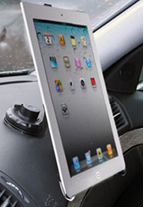
Picture 3.1 Tablet installation in the car dashboard

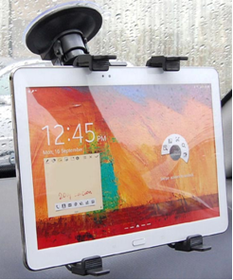
Picture 3.2 Tablet installation on the car windshield

The cradle should be able to support tablet from 8 "inches to 10.1" inches with Adjustable Arm.
Its support base must be CE certified, and it is recommended to be certified or recommended by the car manufacturer.
The base should be 360 ​​degree rotatable and fitted with a suction cup for easy mounting on the windshield or dashboard of the car.
The base must be lined with non-slip soft material to prevent scratches or bumps on the device.

Το The transport information system.
For the purposes of efficient management of electric vehicles and charging stations, an Intelligent Transport Information System should be developed. The construction of the Information System will be based on Artificial Intelligence and the Internet of Things.
This Information System must take into account:
a) The maximum mileage that the electric vehicle can travel,
b) The maximum capacity of the vehicle batteries,
c) The current charge level of the vehicle batteries,
d) The current geographical location of the vehicles
e) Scheduled itineraries for the rest of the day
f) The total kilometers that the vehicle can travel before the next charge
g) The energy requirement for the execution of the other itineraries, based on the kilometers, the altitude difference of the ground and the traffic within the cities
(h) The categorization as to the necessity of all other itineraries
i) The spatial distribution, the availability of time and the power of the existing charging stations in the area.
j) Charging costs per charging station, per day.
The information system will be based on artificial intelligence. Its decision algorithms will accept as input all the above information as input data and will provide the driver of the electric vehicle with information on:
(i) The optimal route of each route.
(ii) The other routes to be performed and their total kilometer.
(iii) The remaining driving time based on the remaining battery capacity.
(iv) The percentage of available battery capacity
(v) The nearest charging stations, their availability and charging capacity.
vi) Suggested charging time and the cost of this charging.
All information transmission between the electric car and the information system will be via the 4G LTE wireless network. An Android application must be built to connect the battery of the electric car and the information system. This application will read the battery status of the vehicle and its geographical location. This information will be transmitted over the 4G network at regular intervals to the Information System. The Information System will process all input data a) to j) and provide the information i) to vi) to the EV driver.
The implementation of the Artificial Intelligence Information System will be developed based on the Tensorflow and Keras software applications. TensorFlow and Keras are software supported by google, popular for creating neural networks and machine learning applications. They will have inputs information from a) to j), and train and maintain a flowchart. The main advantage of TensorFlow is that it can run on different platforms as well as GPUs. TensorFlow was developed in C ++ and can be used by other software, such as Python.
For the implementation of the above system, the Procurement of a communication and monitoring system of electric vehicles of the municipality (two electric vehicles) should be done. The system will consist of three main subsystems: (i) the backend together with the Database, hosted on a web server, (ii) the administrator frontend, which is a web application, and (iii) the user frontend, which is a mobile application.
The backend of the system will communicate with the central data system of the manufacturer and will receive the data of the electric vehicles with appropriate authentication, through secure protocols, through the cloud of the manufacturer. This data will be stored in the project database.
The functions of the system will be managed by an administrator (application and database administrator) through the frontend web application. Through the web environment, the administrator will be able to add / remove cars and charging stations from the system, shut down cars in case of failure and have the general supervision of the system.
The web server software, ie the web application will communicate with the central data system using secure OAuth authentication and will provide data / information for each electric vehicle. The mobile application that will be created will enable the user to see the above information for each vehicle and to be able to rent it for a certain period. The user will also be able to see information such as where the available charging stations are, their availability and cost. By using GPS from the mobile application, the system will be able to use smart algorithms to suggest to the user smart stops for charging or to prevent the user from long distances that will create a problem of energy savings.

The architecture of the higher information system

The architecture of the information system and the dissemination of information is shown in picture 5.1.
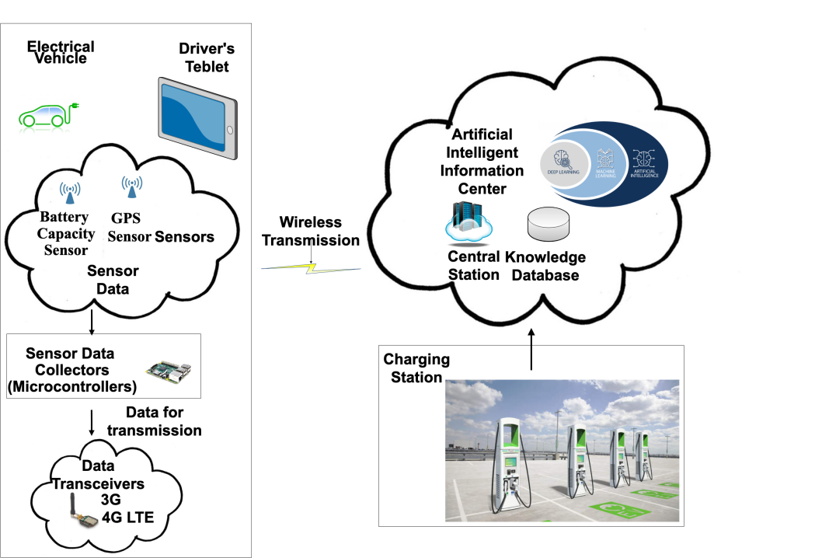
Picture 5.1 The architecture of the Information Transmission System

As it can be seen from the picture, the information collected from the car and Tablet sensors, is transmitted over the 4G wireless network to the information system. The information system also collects information via the internet about the available charging stations and transfers the processed information back to the driver with the help of the Tablet.

Preparation of tenders for the supply of the "Intelligent Transport Information System" and the Communication System between the Electric Car and the Information System

For the preparation of the offers, the attached offer search form was prepared which should be given to at least three software companies with experience in software production for Transport Information Systems.

