ANNEX II + III: TECHNICAL SPECIFICATIONS + TECHNICAL OFFER

Contract title: Supply, delivery, and installationof monitoring and management equipment for water supply system p 1 /…
Publication reference:CN1-S.O 2.3-SC011/TD4

Columns 1-2 should be completed by the contracting authority
Columns 3-4 should be completed by the tenderer
Column 5 is reserved for the evaluation committee
Annex III - the contractor's technical offer
The tenderers are requested to complete the template on the next pages:
- Column 2 is completed by the contracting authority shows the required specifications (not to be modified by the tenderer),
- Column 3 is to be filled in by the tenderer and must detail what is offered (for example the words ‘compliant’ or ‘yes’ are not sufficient)
- Column 4 allows the tenderer to make comments on its proposed supply and to make eventual references to the documentation
The eventual documentation supplied should clearly indicate (highlight, mark) the models offered and the options included, if any, so that the evaluators can see the exact configuration. Offers that do not permit to identify precisely the models and the specifications may be rejected by the evaluation committee.
The offer must be clear enough to allow the evaluators to make an easy comparison between the requested specifications and the offeredspecifications.
Unless otherwise specified, the requirements in these Technical Specifications are presented as a minimum standard which the offered goods must meet in order to be compliant. Tenderers may not submit a variant solution for the items required in these Technical Specifications. When brand names are used in the technical specifications, they are “used in descriptive purposes only” since there is no other comprehensive description possible.
0.1 Minimum requirements and supporting documentation
• Tenderers are required to demonstrate that the offered specifications are responsive to the Tender Dossier requirements identifying model, manufacturer and country of origin of each individual item in their Technical Offer. Tenderers are to provide necessary documentation (catalogues, guides, brochures, manuals, booklets, etc.) with detailed technical specifications of all items being offered thus enabling the Contracting Authority to verify the information provided in the offer.
0.2 Completeness of the supply
• Supply delivery, including installation, integration and final customization must include all needed parts, accessories and consumables required for the supplies to be presented for provisional acceptance fully installed, operational and ready for use.
• Consumables, accessories, parts and documentation used during delivery, installation, integration and customization before provisional acceptance must therefore be anticipated and calculated into the offer.
• It shall be the sole responsibility of the Contractor to ensure that all pre-requisites for the completeness of the supply delivery are met before its commencement.
0.3 Supply delivery
• The equipment must have ability to be connected to the standard Beneficiary Country single phase power output connections.
0.4 Software Licensing
Successful Tenderer must license all software to the Beneficiary to allow designated Beneficiary personnel to perform software installation, update/upgrade, repair/debug and diagnosis/report activities without any external assistance.
0.5 General Requirements
The equipment must include all the necessary parts and must comply with standards for its use.
User manuals for the equipment must be provided in English.
During the warranty period, the Tenderer shall provide technical service and shall replace any defective part of the system supplied with new, including labour for fitting the part and setting up the system. The response time should be not later than 72 hours after the reporting of the failure. If repair is not possible within a reasonable period, the equipment shall be replaced with a similar item of at least equivalent specifications and standard.
Each item must have marking in accordance the Communication and Visibility in EU-financed external actions requirements (https://ec.europa.eu/europeaid/work/visibility/_en) and a serial number on the body of the unit. Correct size and design of sticker and wording will be provided to the Contractor by the Contracting Authority. Production and placement of stickers must be calculated in the price of the vehiacle..
0.6 Installation

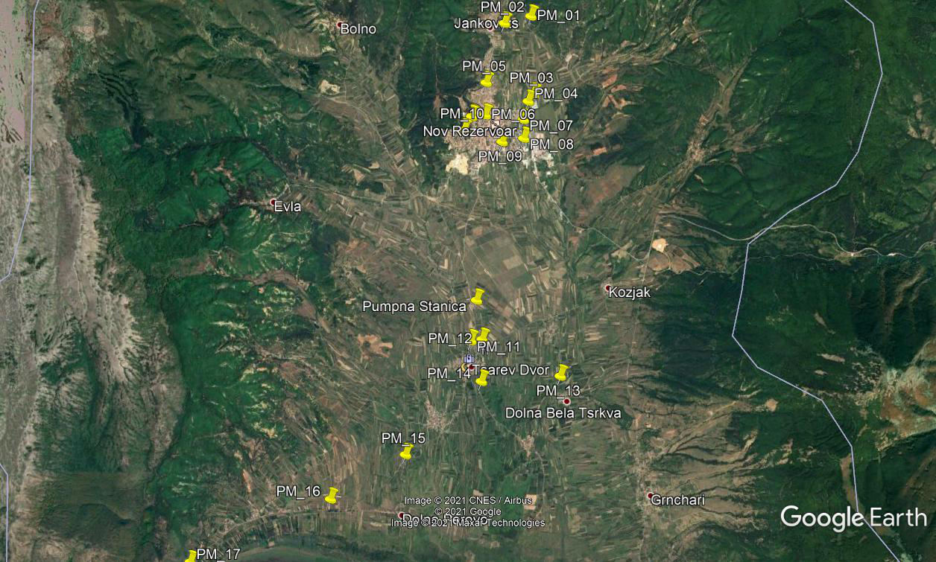
Equipment should be fully operational upon delivery. In addition there is a list with Locations for installation of monitoring and management equipment for water supply system in Resen.
0.7 Testing
Testing (verification of functionality) of complete equipment in the presence of representatives of the end users.

1.  Item number | 2.  Specifications required |  | 3.  Specifications offered | 4.  Notes, remarks,  ref to documentation | 5.  Evaluation committee’s notes
 | Monitoring and management equipment for water supply system consisted of:
1. | Electrical enclosure for electrical and communication equipment – type 1 for remote sensors  Quantity: 15 | Manufacturer’s name:  Product type, model:  Specifications:  - Metal box  - Box dimensions of at least 500×500 mm  - Degree of protection of box of at least IP65  - Degree of mechanical protection of at least IK10  - Thermostat  - Automatic circuit breakers  - DC type  - Rated current of 2A  - 2 poles  - Electrical heater  - Heater supply voltage of 12V  - Heater power between 10 and 20W  - LiYCY low-frequency data cable 3×0.75mm²  - Cable length of at least 25m  Warranty: minimum 1 year
2. | Electrical enclosure for electrical and communication equipment – type 2 for remote actuators and SCADA central station  Quantity: 4 | Manufacturer’s name:  Product type, model:  Specifications:  - Metal box  - Box dimensions of at least 500×500 mm  - Degree of protection of box of at least IP65  - Degree of mechanical protection of at least IK10  - Thermostat  - Automatic circuit breaker (DC type, rated current of 2A, 2 poles)  - Automatic circuit breaker (AC type, rated current of 16A, 1 pole)  - Automatic circuit breaker (AC type, rated current of 10A, 1 pole)  - Automatic circuit breaker (AC type, rated current of 4A, 1 pole)  - Electrical heater  - Heater supply voltage of 12V  - Heater power between 10 and 20W  - Voltage rectifier 220VAC/24VDC, current 2.5 A  - LiYCY low-frequency data cable 3×0.75mm²  - Cable length of at least 50m  - HMI display, screen size at least 7”  Warranty: minimum 1 year
3. | Personal computer – type 1 (server)  Quantity: 1 | Manufacturer’s name:  Product type, model:  Specifications:  - Operating System Windows Server or Microsoft Windows 10 Pro  - Processor equivalent to Intel® Xeon® E-2126G or better  - Gigabit Ethernet port  - Memory of at least 2TB HDD  - ECC UDIMM, at least 16GB  - SATA controller, supporting AHCI mode (non-RAID) or Intel RSTe software RAID (RAID 0, 1, 10, 5)  - Keyboard, mouse  - Licensed SCADA application software  - SCADA server application must be programmed according to demands and necessities of the water supply SCADA system  Warranty: minimum 5 years
4. | Personal computer – type 2 (client)  Quantity: 1 | - Operating System Microsoft Windows 10 Pro  - Processor equivalent to Intel Core i3-10100 or better  - Memory of at least 512 GB SSD  - RAM memory of at least 8GB DDR4  - Integrated Ethernet 100/1000M, VGA, HDMI ports  - Monitor of at least 27”, LCD panel type, aspect ratio of 16:9, must contain VGA, HDMI, audio ports  - Keyboard, mouse  - Licensed SCADA application software  - SCADA client application must be programmed according to demands and necessities of the water supply SCADA system  Warranty: minimum 1 year
5. | Programmable logic controller – type 1  Quantity: 1 | Manufacturer’s name:  Product type, model:  Specifications:  - At least 4 analog inputs  - Current signal 0-20mA on input, sinking type  - Input resolution of at least 13 bits  - External power requirement of 24VDC  - At least 2 digital outputs, sourcing type  - 24VDC operating and supplying voltage  - Ladder memory of at least 8k steps  - User data memory of at least 16KB  - Ethernet 10/100 Base-T (RJ45) port  - RS232 serial port  - Must support Modbus TCP Client/Server and Modbus RTU Master/Slave  - Must have retentive memory and battery backup  - Must contain at least 2 of each: up/down counters, bidirectional counters, single input timers, dual input timers, input interrupts, output interrupts  - Licensed PLC application software  - PLC must be programmed according to demands and necessities of the water supply SCADA system  Warranty: minimum 1 year
6. | Programmable logic controller – type 2  Quantity: 1 | Manufacturer’s name:  Product type, model:  Specifications:  - At least 2 analog inputs  - Current signal 0-20mA on input, sinking type  - Input resolution of at least 13 bits  - External power requirement of 24VDC  - At least 1 analog output  - Current signal 4-20mA on output, sourcing type  - Output resolution of at least 12 bits  - External power requirement of 24VDC  - 24VDC operating and supplying voltage  - Ladder memory of at least 8k steps  - User data memory of at least 16KB  - Ethernet 10/100 Base-T (RJ45) port  - RS232 serial port  - Must support Modbus TCP Client/Server and Modbus RTU Master/Slave  - Must have retentive memory and battery backup  - Must contain at least 2 of each: up/down counters, bidirectional counters, single input timers, dual input timers, input interrupts, output interrupts  - Licensed PLC application software  - PLC must be programmed according to demands and necessities of the water supply SCADA system  Warranty: minimum 1 year
7. | Programmable logic controller – type 3  Quantity: 1 | Manufacturer’s name:  Product type, model:  Specifications:  - At least 1 analog input  - Current signal 0-20mA on input, sinking type  - Input resolution of at least 13 bits  - External power requirement of 24VDC  - 24VDC operating and supplying voltage  - Ladder memory of at least 8k steps  - User data memory of at least 16KB  - Ethernet 10/100 Base-T (RJ45) port  - RS232 serial port  - Must support Modbus TCP Client/Server and Modbus RTU Master/Slave  - Must have retentive memory and battery backup  - Must contain at least 2 of each: up/down counters, bidirectional counters, single input timers, dual input timers, input interrupts, output interrupts  - Licensed PLC application software  - PLC must be programmed according to demands and necessities of the water supply SCADA system  Warranty: minimum 1 year
8. | GPRS router  Quantity: 16 | Manufacturer’s name:  Product type, model:  Specifications:  - Frequency bands 850/900/1800/1900 MHz  - Must support RS232 serial interface  - Must have at least 2 analog inputs with 4...20mA or 0-10VDC  - Power supply of 8...30VDC  - Power consumption of at most 3W in active mode  - Must have sleep (low consumption) mode  - Must be DIN rail mountable  - Must have GSM 50 Ohm antenna  - Must have SIM card slot MiniSIM  - Must have at least IP40 protection  Operating temperature range of at least -20 to 70ºC  Warranty: minimum 1 year
9. | 3G industrial router/gateway  Quantity: 3 | Manufacturer’s name:  Product type, model:  Specifications:  - Must support 3G (UMTS/HSPA+)  - Must support GSM/GPRS/EDGE on 900/1800 MHz  - Network: TCP/IP, UDP/IP, DNS, DHCP client, DHCP server, DynDNS  - Routing: NAT, Static route, PAT, Port forwarding, RIP, VRRP  - Must provide at least 2 VPN tunnels  - Must support AES, 3DES, Blowfish encryption  - Must have 10/100 Base-T RJ45 Ethernet port  - Must have USB connection port  - Must have serial RS232 and/or RS485 port  - Must contain at least 2 general purpose I/O ports  - Power supply of 9-36VDC  - Must be DIN rail mountable  Operating temperature range of at least -20 to 70 ºC  Warranty: minimum 1 year

